Key Vocabulary and Definitions:

Branching database | Used to classify groups of objects. It is used to help identify the objects by answering questions with either yes or no.
Collect | Data that is needed.
Devices | Hardware that can be used for computing.
Display | What data to show to others
Database  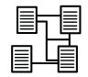 | A collection of information organized in such a way that it can be searched and information found easily.
Evaluate | Look back on our work to discuss what went well and how it could improve.
Graph | A diagram showing the value of objects
Software | Programs used on a computer or other computing device.

Progression
This unit progresses learners’ knowledge and understanding of the categories of data handling, with a particular focus on implementation. It builds on their knowledge of data and information from key stage 1. They will continue to develop their understanding of attributes and begin to construct and interrogate branching databases as a means of displaying and retrieving information.

Curriculum Links:
- Select, use and combine a variety of software (including internet services) on a range of digital devices to design and create a range of programs, systems and content that accomplish given goals, including collecting, analysing, evaluating and presenting data and information.
- Use technology safely, respectfully and responsibly.

Teaching Sequence:
- To investigate questions with yes/no answers and select an attribute to separate objects into groups.
- To identify the attributes needed to collect data about an object.
- To create a branching database.
- To explain why it is helpful for a database to be well structured.
- To plan the structure of a branching database.
- To independently create an identification tool.

Online Safety: Health, well-being and lifestyle:
1. To explain why spending too much time using technology can sometimes have a negative impact on anyone.
2. To give some examples of both positive and negative activities where it is easy to spend a lot of time engaged (e.g. doing homework, games, films, videos).
3. To explain why some online activities have age restrictions.
4. To understand why it is important to follow age restrictions and know who I can talk to if others pressure me to watch or do something online that makes me feel uncomfortable.
5. To explain the smart rules with a focus on the T in Smart (Tell)

Blooms Taxonomy – Specific Verbs to Use in Lesson Aims
Knowledge: Describe, find, identify, list, locate, name, recognise, retrieve Comprehension: Classify, compare, explain, infer, interpret, paraphrase, summarise Application: Carry out, implement, use Analysis: Deconstruct, Organise, outline, structure Synthesis: Construct, design, devise, invent, make, plan, produce, Evaluation: Appraise, assess, choose,

Final outcome
To create a branching database using Teach Computing

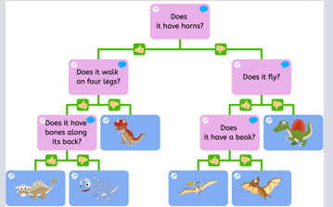

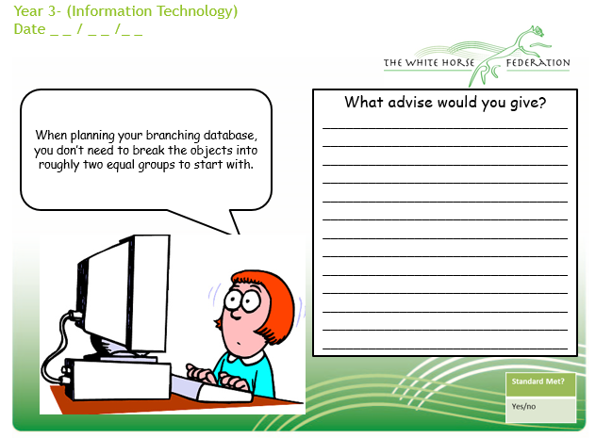

Aims | Advice
1. I can explain why spending too much time using technology can sometimes have a negative impact on anyone.

2. I can give some examples of both positive and negative activities where it is easy to spend a lot of time engaged (e.g. doing homework, games, films, videos)

3. I can explain why some online activities have age restrictions.

4. I can understand why it is important to follow age restrictions and know who I can talk to if others pressure me to watch or do something online that makes me feel uncomfortable.

5. I can explain the smart rules with a focus on the T in Smart (Tell)

