Key Vocabulary and Definitions:

Fertilisation  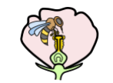 | The process where pollen meets the egg and a seed is formed.
Flower  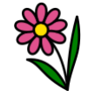 | A flower is the part of a plant that blossoms.
Petal  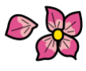 | The petals are the bright, colourful leaves of the flower which attract insects.
Pollination  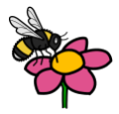 | Pollination is the process by which flowers form seeds. This is how plants reproduce.
Seed  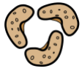 | Seeds come in all sizes, shapes and colors depending on the type of plant.
Photosynthesis  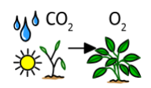 | The way plants turn light into energy. This is how a plant makes its own food.

What should I already know?
- Observe and describe how seeds and bulbs grow into mature plants. (Y2 - Plants)
- Find out and describe how plants need water, light and a suitable temperature to grow and stay healthy. (Y2 - Plants)

Scientific knowledge:
- Identify and describe the functions of different parts of flowering plants: roots; stem/trunk; leaves; and flowers.
- Explore the requirements of plants for life and growth (air, light, water, nutrients from soil, and room to grow) and how they vary from plant to plant.
- Investigate the way in which water is transported within plants.
- Explore the part that flowers play in the life cycle of flowering plants, including pollination, seed formation and seed dispersal.

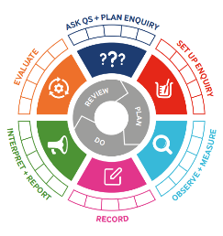
Teaching Sequence

- To identify the parts of a flowering plant.
- To understand the functions of a flowering plant.
- To investigate the way in which water is transported within plants (TAPS)
- To understand the process of how fruits develop from pollinated flowers.
- To classify fruits according to observable similarities and differences.
- To understand that the function of a fruit is to produce and disperse seeds.

Blooms Taxonomy – Specific Verbs to Use in Lesson Aims
Knowledge: Describe, find, identify, list, locate, name, recognise, retrieve Comprehension: Classify, compare, explain, infer, interpret, paraphrase, summarise Application: Carry out, implement, use Analysis: Deconstruct, Organise, outline, structure Synthesis: Construct, design, devise, invent, make, plan, produce, Evaluation: Appraise, assess, choose,

Key Knowledge

Term 6 | Let’s Talk (Explorify) | Scientific Knowledge | Scientific Skill
Lesson 1 | Odd One Out  https://explorify.uk/en/activities/odd-one-out/friends-of-flowers | - Identify and describe the functions of different parts of flowering plants: roots; stem/trunk; leaves; and flowers. | Observe and Measure
Lesson 2 | What if …  https://explorify.uk/en/activities/what-if/plants-could-talk | - Explore the part that flowers play in the life cycle of flowering plants, including pollination, seed formation and seed dispersal. | Ask questions and plan enquiry
Lesson 3 | Odd One Out  https://explorify.uk/en/activities/odd-one-out/what-is-inside-flowers | - Explore the part that flowers play in the life cycle of flowering plants, including pollination, seed formation and seed dispersal. | Ask questions and plan enquiry
Lesson 4 | Spectacular Spheres  https://explorify.uk/en/activities/zoom-in-zoom-out/spectacular-spheres | - Explore the part that flowers play in the life cycle of flowering plants, including pollination, seed formation and seed dispersal. | Evaluate
Lesson 5 | Zoom in zoom out  https://explorify.uk/en/activities/zoom-in-zoom-out/pink-and-white | - Explore the part that flowers play in the life cycle of flowering plants, including pollination, seed formation and seed dispersal. | Observe and Measure

