Key Vocabulary and Definitions:

|  |  |
| --- | --- |
| Animation | Animation is a method by which still figures are manipulated to appear as moving images. |
| Flip book | A flipbook is a small book with a series of printed images which create the illusion of motion when the pages of the book are rapidly flipped over. |
| Stop-frame animation | An animation that is captured one frame at time, with physical objects that are moved between |
| frame | A frame is a single, still image displayed by the computer |
| sequence | A particular order in which related things follow each other. |
| image | A visual representation of something |
| photograph | A picture made using a camera |
| Setting | The place or type of surroundings where something is positioned or where an event takes place. |
| character | A person in a novel, play, or film |
| Events | An event is an action or occurrence recognised by software |
| Onion skinning | An editing technique used to see several frames of an animation simultaneously. |

Progression

This unit progresses students’ knowledge and understanding of using digital devices to create media, exploring how they can create stop-frame animations. Following this unit, learners will further develop their video editing skills in Year 5.

Curriculum links

* Select, use and combine a variety of software (including internet services) on a range of digital devices to design and create a range of programs, systems and content that accomplish given goals, including collecting, analysing, evaluating and presenting data and information
* Use technology safely, respectfully and responsibly; recognise acceptable/unacceptable behaviour; identify a range of ways to report concerns about content and contact.

**Teaching Sequence**

1. To explain that animation is a sequence of drawings or photographs
2. To relate animated movement with a sequence of images.
3. To plan an animation and identify the need to work consistently and carefully.
4. To review and improve an animation
5. To evaluate the impact of adding other media to an animation

**Online Safety Teaching: Online Relationships**

1. To describe ways people who have similar interests can get together online.

2. To explain what it means to ‘know someone’ online and why this might be different from knowing someone offline.

3. To explain what is meant by trusting someone online why this is different from liking someone online and why it is important to be careful about who to trust online including what information and content they are trusted with and to explain why someone may change their mind about trusting anyone with something if they feel nervous, uncomfortable or worried

4. To explain how someone’s feelings can be hurt by what is said or written online and to explain the importance of giving and gaining permission before sharing things online; to know the principles of sharing online is the same as sharing offline.

5. Recap the SMART rules, Meet and Tell

Blooms Taxonomy – Specific Verbs to Use in Lesson Aims

Knowledge: Describe, find, identify, list, locate, name, recognise, retrieve Comprehension: Classify, compare, explain, infer, interpret, paraphrase, summarise Application: Carry out, implement, use Analysis: Deconstruct, Organise, outline, structure Synthesis: Construct, design, devise, invent, make, plan, produce, Evaluation: Appraise, assess, choose,

Fina outcome

To create a stop motion animation using 2animate on the ipads.

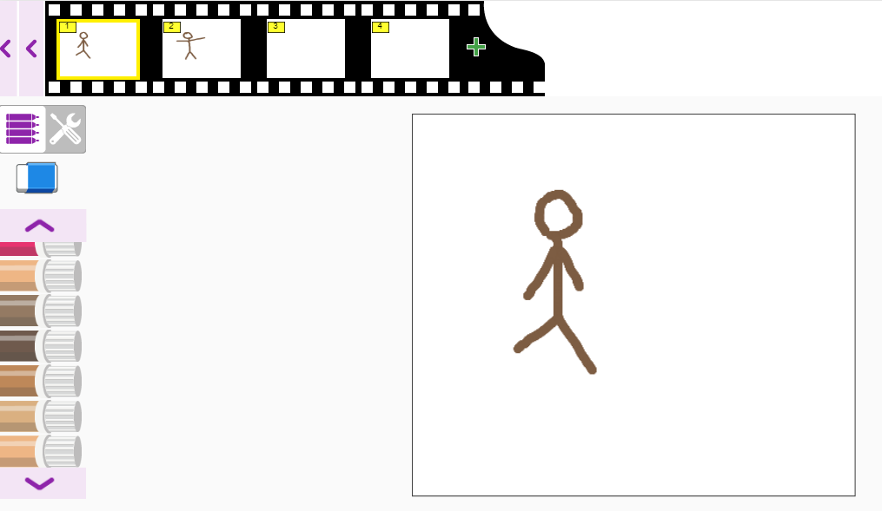

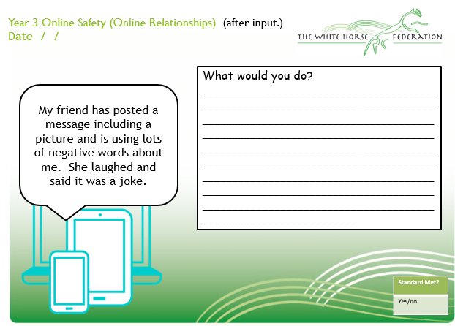

|  |  |
| --- | --- |
| Aims | Advice |
| 1. To describe ways people who have similar interests can get together online. |  |
| 2. To explain what it means to ‘know someone’ online and why this might be different from knowing someone offline. |  |
| 3. To explain what is meant by trusting someone online why this is different from liking someone online and why it is important to be careful about who to trust online including what information and content they are trusted with and to explain why someone may change their mind about trusting anyone with something if they feel nervous, uncomfortable or worried |  |
| 4. To explain how someone’s feelings can be hurt by what is said or written online and to explain the importance of giving and gaining permission before sharing things online; to know the principles of sharing online is the same as sharing offline. |  |
| 5. Recap the SMART rules, Meet and Tell |  |