Key Vocabulary and Definitions:

|  |  |
| --- | --- |
| Climate | The weather over a period of time including temperature and rainfall |
| Continent | A large area of the land on Earth that is joined together. There are seven continents in the world. |
| Hemisphere | One of the halves into which the earth is divided (North/South or East/West) |
| Human features | Ways in which people have affected an area |
| Physical features | The natural features of an area, such as mountains, deserts, rivers, and oceans. |
| Population | The number of people living in a country, city, or area |
| Similarities | Things that are the same or similar between 2 places or ways of life |

What should I already know?

* Identify seasonal/daily weather patterns in the UK and the location of hot and cold areas of the world in relation to the equator and the North and South poles
* Use basic Geographical vocabulary to refer to key physical features
* Use 4 points of a compass

Geographical Skills:

* Describe and understand key aspects of Physical geography including key topographical features (including hills, mountains, coasts, rivers) and land patterns; and understand how some of these aspects have changed over time.
* Use maps, atlases, globes and digital/computer mapping (Google Earth) to locate countries and describe features studied.

Teaching Sequence

1. To explore India and research related facts.
2. To explore the difference between the physical and human geography.
3. Explore India’s human geography.
4. To explore the mountain ranges found in India.
5. To explore some of the major rivers in India.
6. To compare India to the United Kingdom.

Blooms Taxonomy – Specific Verbs to Use in Lesson Aims

Knowledge: Describe, find, identify, list, locate, name, recognise, retrieve Comprehension: Classify, compare, explain, infer, interpret, paraphrase, summarise Application: Carry out, implement, use Analysis: Deconstruct, Organise, outline, structure Synthesis: Construct, design, devise, invent, make, plan, produce, Evaluation: Appraise, assess, choose,

Key Knowledge

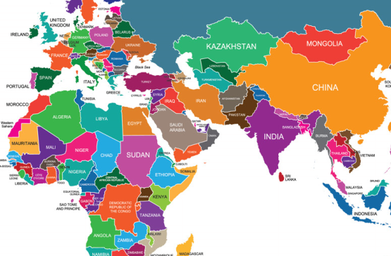

Mountain Types

