Technical Knowledge and skills:

- To measure with some accuracy and join materials, cut them with some independence.
- To describe differences in materials independently
- To suggest ways to make material/product stronger independently.
- To begin to make strong structures.
What should I already know?
- Discuss and evaluate the existing products to understand their purpose. Discus the given design brief and the design criteria.
- Design their own product using labelled drawings. Be able to discuss what resources they require for their products.
- Based on their individual designs, choose from a variety of materials and perform practical skills e.g cutting joining and finishing the product with some independence etc
- Testing their products.
- Evaluate their ideas and products against the design criteria provided using a sheet with sentence starters.

Key Vocabulary:
Stiffen  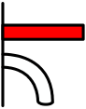 | Make rigid or strong
Bridle  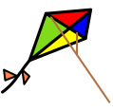 | The arrangement of strings that go between a kite and the flying line.
Frame   | A rigid structure that surrounds something
Spars  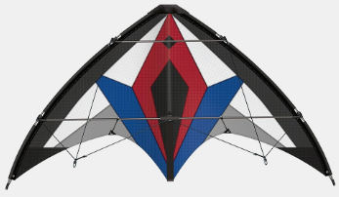 | The rod or sticks used as the frame of a kite.
Keel  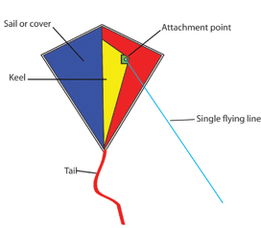 | A vertical piece of sail material beneath the kite like the keel of a boat

DT Skills:
Design:
Investigate and evaluate the existing products to understand their purpose. Discus the given design brief. As a class, create their design criteria. Design their own product using labelled drawings. List all the resources that they require for the product.
Make:
Basedon their individual designs, choose from a variety of materials and perform practical skills e.g measuring, cutting joining and finishing the product independently.
Evaluate:
Testing their products. Evaluate their ideas and products against the design criteria using a given sheet with leading questions.

Blooms Taxonomy – Specific Verbs to Use in Lesson Aims
Knowledge: Describe, find, identify, list, locate, name, recognise, retrieve Comprehension: Classify, compare, explain, infer, interpret, paraphrase, summarise Application: Carry out, implement, use Analysis: Deconstruct, Organise, outline, structure Synthesis: Construct, design, devise, invent, make, plan, produce, Evaluation: Appraise, assess, choose,

Focused designer/ company
History of kites in China
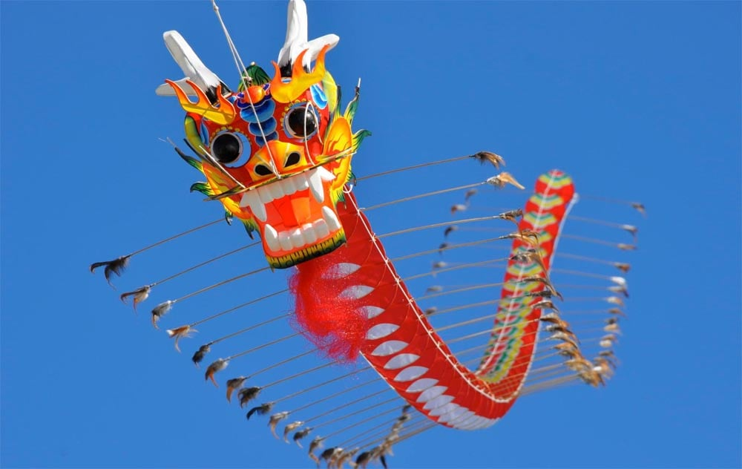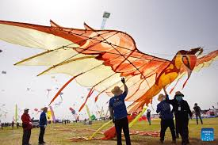

Key Knowledge

Kite Structure:
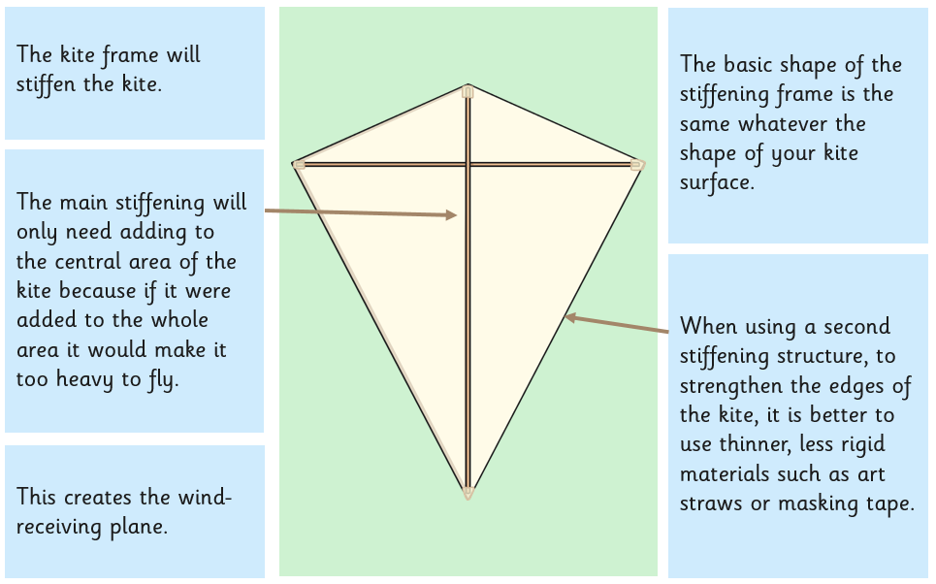
Joining Techniques:
