Technical Knowledge and skills:

* To measure with some accuracy and join materials, cut them with some independence.
* To describe differences in materials independently
* To suggest ways to make material/product stronger independently.
* To begin to make strong structures.

What should I already know?

* Discuss and evaluate the existing products to understand their purpose. Discus the given design brief and the design criteria.
* Design their own product using labelled drawings. Be able to discuss what resources they require for their products.
* Based on their individual designs, choose from a variety of materials and perform practical skills e.g cutting joining and finishing the product with some independence etc
* Testing their products.
* Evaluate their ideas and products against the design criteria provided using a sheet with sentence starters.

Key Vocabulary:

|  |  |
| --- | --- |
| Stiffen | Make rigid or strong |
| Bridle | The arrangement of strings that go between a kite and the flying line. |
| Frame | A rigid structure that surrounds something |
| Spars | The rod or sticks used as the frame of a kite. |
| Keel  Planetpals Craft Page: Make recycle paper kite from schoolwork Fun nature  recycle project with the kids! Building plans, layouts, patterns, ideas,  directions | A vertical piece of sail material beneath the kite like the keel of a boat |

DT Skills:

Design:

Investigate and evaluate the existing products to understand their purpose. Discus the given design brief. As a class, create their design criteria. Design their own product using labelled drawings. List all the resources that they require for the product.

Make:

Based on their individual designs, choose from a variety of materials and perform practical skills e.g measuring, cutting joining and finishing the product independently.

Evaluate:

Testing their products. Evaluate their ideas and products against the design criteria using a given sheet with leading questions.

Blooms Taxonomy – Specific Verbs to Use in Lesson Aims

Knowledge: Describe, find, identify, list, locate, name, recognise, retrieve Comprehension: Classify, compare, explain, infer, interpret, paraphrase, summarise Application: Carry out, implement, use Analysis: Deconstruct, Organise, outline, structure Synthesis: Construct, design, devise, invent, make, plan, produce, Evaluation: Appraise, assess, choose,

Focused designer/ company  
History of kites in China

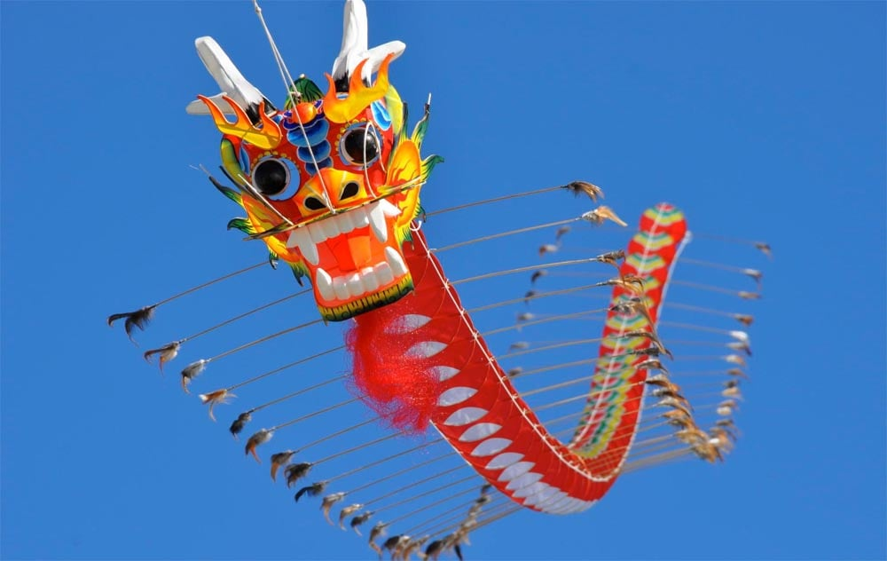 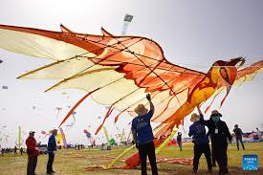

Key Knowledge

Kite Structure:

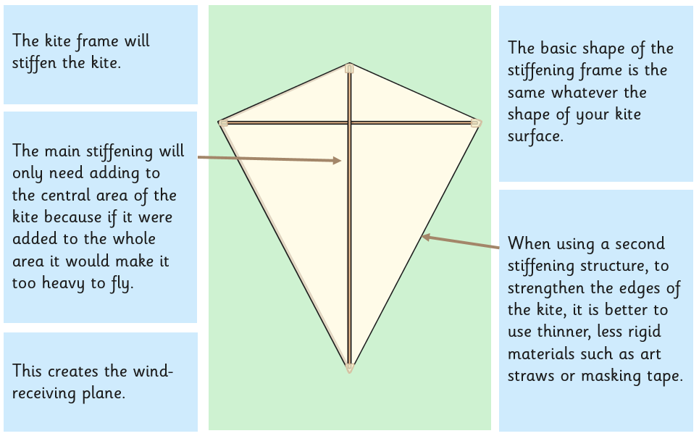

Joining Techniques:

