Key Vocabulary and Definitions:

|  |  |
| --- | --- |
| Archaeology | The study of things that people made, used, and left behind. |
| Cartouche | A nameplate for Egyptian coffins. |
| Canopic Jars | Used to store organs which were removed from a dead person. |
| Hieroglyphics | A writing system that uses pictures and symbols instead of letters and words. |
| Irrigation | Watering land to make it suitable to grow crops. |
| Mummification | A way to prepare a dead body for the afterlife. |
| Pharaoh | Egyptian Kings or Emperors. |
| Pyramids | The stone tombs of Egypt's kings. |
| Sarcophagus | A stone container for a coffin or body. |
| Tomb | A place for the burial of a dead body. |

What should I already know?

* History is divided into BC and AD.
* Historical artefacts and written evidence can be used to give us information about the past
* Use common words and phrases relating to the passing of time.

Historical Skills:

* Sequence events or artefacts;
* Understand why people may have had to do something
* Identify reasons for and results of people’s actions.
* Distinguish between different sources and evaluate their usefulness
* Use a range of sources to find out about a period
* Observe small details – artefacts, pictures.
* Select and record information relevant to the study
* Communicate their knowledge through discussion, drawing pictures, drama/ role play, making models, writing and using ICT (cross-curricular with Art this term)

Teaching Sequence

1. To understand where Egypt is and why Ancient Egypt is significant.
2. To explore the daily lives of Ancient Egyptians.
3. To learn about the role of pharaohs and the pyramids.
4. To explore the beliefs and mythology of Ancient Egypt
5. To understand the importance of the Ancient Egyptian writing system.
6. To understand the impact of Ancient Egypt on the modern world.

Blooms Taxonomy – Specific Verbs to Use in Lesson Aims

Knowledge: Describe, find, identify, list, locate, name, recognise, retrieve Comprehension: Classify, compare, explain, infer, interpret, paraphrase, summarise Application: Carry out, implement, use Analysis: Deconstruct, Organise, outline, structure Synthesis: Construct, design, devise, invent, make, plan, produce, Evaluation: Appraise, assess, choose,

Key Knowledge

Timeline of Key Events: Egyptian Gods:

|  |  |
| --- | --- |
| 7500 BC | The first settlers arrived in the Nile Valley. |
| 3200 BC | Hieroglyphs are used for the first time. |
| 2640 BC | The first pyramid is built. |
| 2555 BC | Giza pyramids are built. |
| 2520 BC | The Sphinx is built. |
| 2200 BC | First ploughs are attached to oxen. |
| 1539 BC | Valley of the Kings starts |
| 1332 BC | Rule of Tutankhamun begins |
| 51 BC | Cleopatra’s reign begins. Egyptian civilisation ends. |

World Map Showing Egypt: Map of Africa:

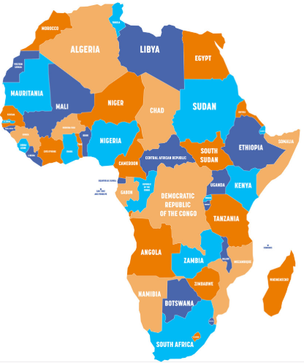

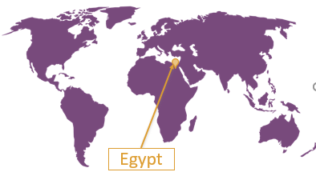

1.Ra 2.Amun 3.Horus 4.Thoth 5.Ma’at   
6. Isis 7.Osiris 8.Hathor 9.Anubis 10.Sekhmet

