Key Vocabulary and Definitions:

Brahman | The supreme power- God
Deities | A god or goddess
Ganesha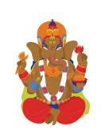 | Deity with the head of an elephant
Lakshmi  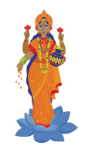 | Goddess of wealth and good fortune
Attributes | A a special quality, feature, or characteristic that belongs to a person, object, or place
Puranas 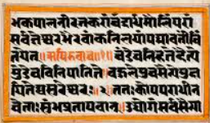 | Ancient Hindu Scripture
Samsara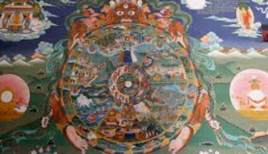 | The cycle of life and death
Trimurti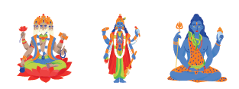 | The three aspects of the universal supreme god
Varanasi | A sacred city on the bank of the Ganges.

What should I already know?
What might Sanatanis learn from the story of Rama and Sita and the celebrations of Diwali? (Year 3)
Does visiting the Ganges make a person a better Sanatani? (Year 3)

RE Skills:
To explain how different aspects of my character help others see who I really am.
To describe different deities and explain why they may be important to Sanatanis.
To explain why or how these deities might tell Sanatanis more about God

Teaching Sequence

- To explain how people show different aspects of their personalities.

- To explain the Santana belief that Brahman is one supreme deity with different aspects.

- To explain what some Sanatanis night believe about Ganesha.

- To explain what some Sanatanis might believe about Lakshmi.

- To describe different deities and explain why they may be important to Sanatanis.

- To explain how I could show more of my positive impact.
Blooms Taxonomy – Specific Verbs to Use in Lesson Aims
Knowledge: Describe, find, identify, list, locate, name, recognise, retrieve Comprehension: Classify, compare, explain, infer, interpret, paraphrase, summarise Application: Carry out, implement, use Analysis: Deconstruct, Organise, outline, structure Synthesis: Construct, design, devise, invent, make, plan, produce, Evaluation: Appraise, assess, choose,

Background Information

Sanatana Dharma Ages 7-9 Enquiry 2:

What do some deities tell Sanatanis about God?

The summaries must not be taken as the beliefs of ALL members of the particular religion. Sanatanis believe that Brahman can appear in many different ways but is always the one supreme being. Many Sanatanis might choose to worship him in one of his different appearances. These are called Deities. It is important throughout this enquiry to consistently reinforce that all deities are Brahman in different forms, not individual gods.

The deities studied in this enquiry have been introduced in ages 5-7 so if the children have not covered this before, you may like to spend longer on the slides in piece 2, especially the Trimurti as they are not the focus of this enquiry. Ganesha and Lakshmi are studied in more detail in pieces 3 and 4. The teacher may wish to read through the Background Enquiry Sheets for ages 5-7 for further background information on the deities and the festival of Diwali.

Brahma: At times Brahman needs to create new life. In this role, he is called Brahma (the names are quite similar so make sure the children do not get them confused.) Brahma is the creator.

Vishnu: Once something is created, it needs the right conditions to help it grow and develop. Its life needs looking after. Another word for this is preserving. In this role, Brahman is called Vishnu. Vishnu is the preserver of life.

Shiva: At the end of a season or a life, things come to an end. The old things are destroyed so that new life can come in its place. In this role, Brahman is called Shiva. Shiva is the destroyer -it is the side of Brahman that deals with bringing things to an end.

Shiva and Parvati are believed to be parents to Ganesha. Due to him not realising Ganesha was his son, Shiva cut off his head so replaced it with the head of the nearest sleeping animal which was an elephant. He also granted Ganesha great wisdom and a power to remove any obstacles that come in the way of all people who truly worship him. So before beginning any undertaking or task or any new project or work, a Sanatani might feel it is good to pray to Ganesha for the successful completion of the task undertaken.

Ganesha had a younger brother. One day, they found a special fruit in the forest and took it. They refused to share it with each other, and they both started saying it was theirs. They went to their parents, Shiva and Parvati, and Shiva decided to give them a challenge. He asked them to go round their world 3 times. Whoever did it first and returned would be the rightful own Sanatanis er of the fruit. The younger brother immediately hopped onto his pet peacock and flew speedily to complete three revolutions across the Earth. Ganesha’s pet was a rat who could not fly so he thought carefully about how Shiva had worded the challenge. Then Ganesha started walking around Shiva and Parvati and completed three circles around them before his brother came back. When asked by Shiva what he was doing, Ganesha replied that Shiva had asked them to go around their world. He said that for him, his parents were more than the world. They were the entire universe. Shiva was very impressed with how wisely Ganesh had solved the problem, so gave him the fruit.

Lakshmi: Lakshmi is the goddess of wealth and good fortune. She is also the wife of Vishnu. Lakshmi is worshipped during the festival of Diwali. People hope that Lakshmi will visit them because then they will be luckier. They light lamps and put them in their windows to welcome her and encourage her to come to them. There is a story in the plans about a wise woman who ensured she would be the only one to receive such a visit, modelling that being honest brings its own rewards. When Lakshmi arrived that evening, she found only one light welcoming her to that home, so she blessed the woman and her family with good health and happiness for years to come.

It is quite common for Sanatanis to worship different aspects of Brahman at certain festivals (such as Diwali) however, they will often select one to be their focus for the rest of their lives and have shrines to that deity in their homes.

