Key Vocabulary and Definitions:

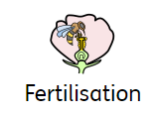 | Fertilisation is the process by which the pollen meets the egg and a seed is formed. Seeds are usually formed in fruit.
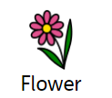 | A flower is the part of a plant that blossoms. Flowers produce the seeds that can become new plants.
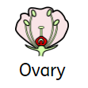 | The ovary of the flower contains ovules which are potential seeds.
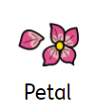 | The petals are the bright colorful leaves of the flower. The petals are often bright and colorful in order to attract insects that help with pollination.
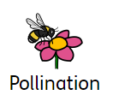 | Pollination is the process by which flowers form seeds. This is how plants reproduce.
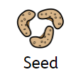 | The seed is the embryo of a plant. Seeds come in all sizes shapes and colors depending on the type of plant.
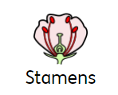 | The stamen is the part of the flower that produces pollen. There are two main parts of the stamen: the filament and anther.
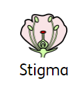 | The stigma is the area where pollen is received. The stigma may be located at the end of a stalk called the style.

What should I already know?
- Observe and describe how seeds and bulbs grow into mature plants. (Y2- Plants)
- Find out and describe how plants need water, light and a suitable temperature to grow and stay healthy. (Y2 - Plants)

Scientific knowledge:

- Identify and describe the functions of different parts of flowering plants: roots; stem/trunk; leaves; and flowers.
- Explore the requirements of plants for life and growth (air, light, water, nutrients from soil, and room to grow) and how they vary from plant to plant.
- Investigate the way in which water is transported within plants.
- Explore the part that flowers play in the life cycle of flowering plants, including pollination, seed formation and seed dispersal.

Teaching Sequence

- To explore the part that flowers play in the life cycle of flowering plants. (Set up the investigation)

- To understand that flowers vary in size, colour, shape and form but all play a crucial role in reproduction.

- To understand the process of how fruits develop from pollinated flowers.

- To classify fruits according to observable similarities and differences.

- To understand that the function of a fruit is to produce and disperse seeds.

Blooms Taxonomy – Specific Verbs to Use in Lesson Aims
Knowledge: Describe, find, identify, list, locate, name, recognise, retrieve Comprehension: Classify, compare, explain, infer, interpret, paraphrase, summarise Application: Carry out, implement, use Analysis: Deconstruct, Organise, outline, structure Synthesis: Construct, design, devise, invent, make, plan, produce, Evaluation: Appraise, assess, choose,
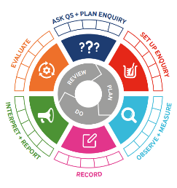

Key Knowledge

Term 6 | Let’s Talk (Explorify) | Scientific Knowledge | Scientific Skill
Lesson 1 | Odd One Out  https://explorify.uk/en/activities/odd-one-out/friends-of-flowers | - Identify and describe the functions of different parts of flowering plants: roots; stem/trunk; leaves; and flowers. | Observe and Measure
Lesson 2 | What if …  https://explorify.uk/en/activities/what-if/plants-could-talk | - Explore the part that flowers play in the life cycle of flowering plants, including pollination, seed formation and seed dispersal. | Observe and Measure
Lesson 3 | Odd One Out  https://explorify.uk/en/activities/odd-one-out/what-is-inside-flowers | - Explore the part that flowers play in the life cycle of flowering plants, including pollination, seed formation and seed dispersal. | Observe and Measure
Lesson 4 | Spectacular Spheres  https://explorify.uk/en/activities/zoom-in-zoom-out/spectacular-spheres | - Explore the part that flowers play in the life cycle of flowering plants, including pollination, seed formation and seed dispersal. | Observe and Measure
Lesson 5 | Zoom in zoom out  https://explorify.uk/en/activities/zoom-in-zoom-out/pink-and-white | - Explore the part that flowers play in the life cycle of flowering plants, including pollination, seed formation and seed dispersal. | Observe and Measure

