What should I already know?

* Able to understand how everyday lives of people in time studied compare with our life today.
* How to use a range of sources to find out about a period.
* How to observe small details – artefacts, pictures.

Key Vocabulary and Definitions:

|  |  |
| --- | --- |
| Amphitheatre | Outdoor theatre |
| Ancient | Belonging to the very distant past and no longer in existence. |
| Artefact | An object made by a human being. |
| Democracy | A system of government where the whole population gets to vote for representatives that will represent them. |
| Greeks | Someone who lives in Greece, or a person of Greek descent. |
| Myths | A traditional story - typically involving supernatural beings or events. |
| Olympics | The greatest of the games – A modern international sports competition held every four years. |
| Philosophy | The practice of asking big questions with no clear or single answer. |

Historical Skills:

*Building on prior knowledge:*

* Develop a broad understanding of ancient civilisations.
* Look for links and effects in time studied.
* Use evidence to build up a picture of a past event.
* Begin to evaluate the usefulness of different sources.
* Choose relevant material to present a picture of one aspect of life in time past.
* Use the internet for research to ask and answer questions.

Teaching Sequence

1. To be able to understand aspects of everyday life in Ancient Greece.
2. To learn about the differences between the Ancient Greek states of Athens and Sparta.
3. To be able to deduce information about Greek beliefs and religious practices from pictures of buildings and pottery.
4. To learn about the impact of the ancient Greek civilisation on the modern world.
5. To design, make and evaluate a Greek pot.

Blooms Taxonomy – Specific Verbs to Use in Lesson Aims

Knowledge: Describe, find, identify, list, locate, name, recognise, retrieve Comprehension: Classify, compare, explain, infer, interpret, paraphrase, summarise Application: Carry out, implement, use Analysis: Deconstruct, Organise, outline, structure Synthesis: Construct, design, devise, invent, make, plan, produce, Evaluation: Appraise, assess, choose,

Key Knowledge

1. Ancient Greeks lived around 2500 years ago.
2. Ancient Greece was divided into several city states, each with their laws and rulers.
3. The most important city states were Athens and Sparta.
4. Alexander the Great was the founder of the Ancient Greek Empire which included Europe, Egypt, and South-West Asia)
5. Ancient Greeks invented theatre.
6. Ancient Greeks held many festivals in honour of their gods.
7. The first Greek Olympics were held on the city of Olympia in 776 BC.
8. The winners of each event (wrestling, boxing, long jump, javelin, discus and chariot racing) were given wreath of leaves.
9. Statues of Greek gods and goddesses were placed inside temples. The most famous one is Pantheon.
10. The most famous gods were Athena and Zeus.

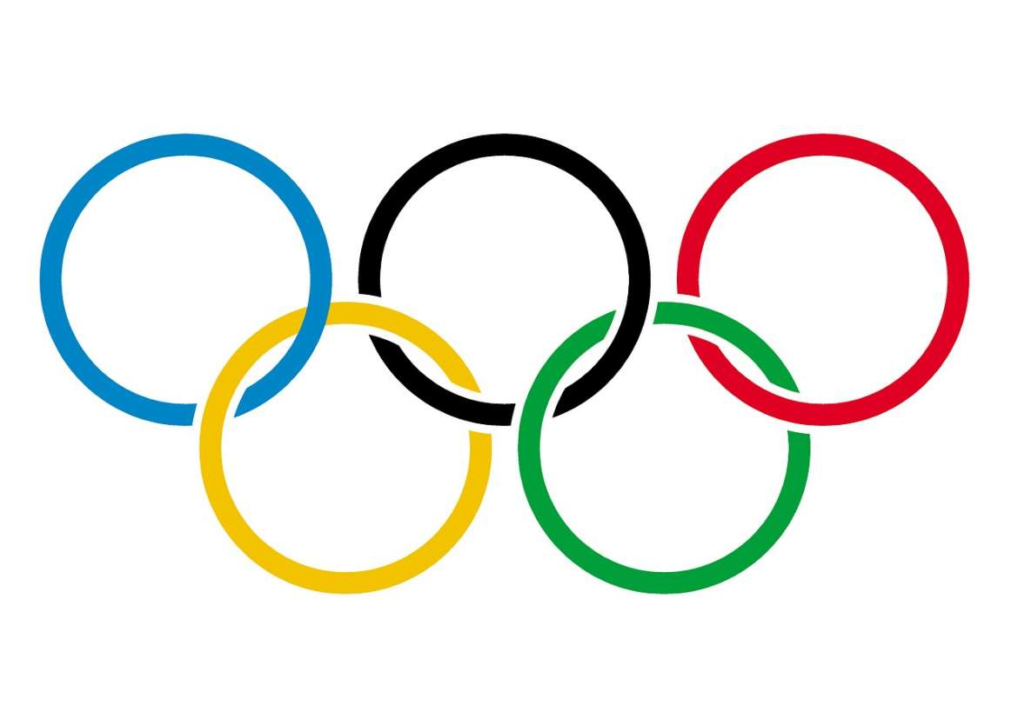

Olympics

Amphitheatre