Key Vocabulary and Definitions:

|  |  |
| --- | --- |
| Tint | It is where an artist adds a colour to white to create a lighter version of the colour |
| Tone | A tone is where an artist adds grey to a colour. |
| Shade | A shade is where an artist adds black to a colour to darken it down. |
| Primary colours | Primary colours include yellow, blue, and red. These are colours that can't be created by mixing of other colours. |
| Secondary colours | A secondary colour is a colour made by mixing of two primary colours in a given colour space. |

What should I already know?

* To apply colour using dotting, scratching and splashing.
* Colour wheel – mood painting.
* To understand and identify key aspects such as complimentary colours, colours as tone, warm and cold colours.

Scientific Skills:

* To create different effects by using a variety of tools and techniques such as bleeds, washes, scratches and splashes.
* To colour mixing and matching; tint, tone, shade

Teaching Sequence

1. To use a variety of paper types and explore different mediums (crayon, oil pastels, coloured pencils) when creating leaf prints.
2. To know how to mix colours to create different tones, tints or shades
3. To create different effects by using bleeding and washing technique
4. To create a painting in Paul Klee’s style
5. To create different effects by using the splashing technique

Blooms Taxonomy – Specific Verbs to Use in Lesson Aims

Knowledge: Describe, find, identify, list, locate, name, recognise, retrieve Comprehension: Classify, compare, explain, infer, interpret, paraphrase, summarise Application: Carry out, implement, use Analysis: Deconstruct, Organise, outline, structure Synthesis: Construct, design, devise, invent, make, plan, produce, Evaluation: Appraise, assess, choose,

Key Knowledge

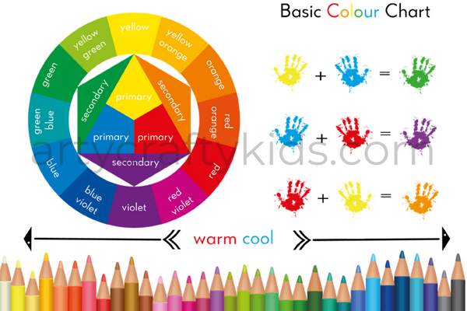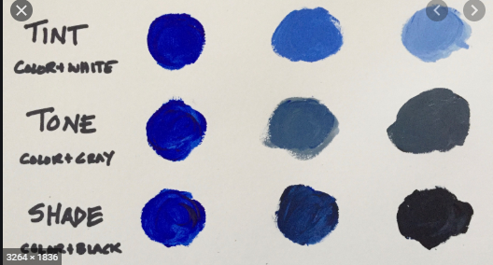

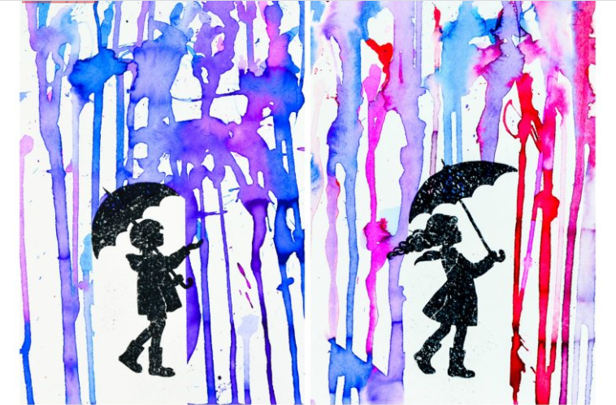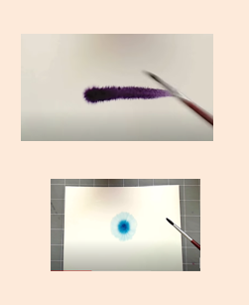**Paul Klee**