Key Vocabulary and Definitions:

Biomes  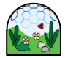 | A large naturally community of flora and fauna (plants) occupying a habitat, e.g. forest
Climates  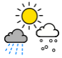 | The usual weather conditions in an area over a long period.
Equator  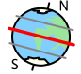 | An imaginary circle around Earth. It runs east and west halfway between the North and South poles.
Flora  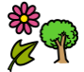 | The plants of a particular region, habitat
Fauna  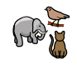 | The animals of a particular region, habitat
Globe  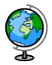 | A spherical model of Earth.
Habitat   | The natural home or environment of an animal or plant.
Hemisphere  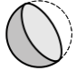 | Half of the Earth. Divided by North and South.
Tropics  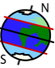 | The region of the Earth near to the equator.
Vegetation Belts  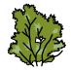 | Certain plant species live in 5 different regions of the world, depending upon climate. The 5 regions are: forest, grassland, tundra, desert, and ice.

What should I already know?
- Identify seasonal/daily weather patterns in the UK and the location of hot and cold areas of the world in relation to the equator and the North and South poles.

- Use basic Geographical vocabulary to refer to key physical features (inc – beach, cliff, coast, forest, hill, mountain, sea, ocean, river, soil, valley, vegetation, season, weather).

Geography Skills:
- Identify the position and significance of Equator, N. and S. Hemisphere, Tropics of Cancer and Capricorn.

- To describe and understand key aspects of: Physical geography, including: climate zones, biomes and vegetation belts (link to work on Rainforest).

Blooms Taxonomy – Specific Verbs to Use in Lesson Aims
Knowledge: Describe, find, identify, list, locate, name, recognise, retrieve Comprehension: Classify, compare, explain, infer, interpret, paraphrase, summarise Application: Carry out, implement, use Analysis: Deconstruct, Organise, outline, structure Synthesis: Construct, design, devise, invent, make, plan, produce, Evaluation: Appraise, assess, choose,

Teaching Sequence

- To identify the position and significance of latitude, longitude, Equator.
- To understand what climate and climate zones are
- To locate the climate zones across the world
- To understand what biomes are and where they are located across the world.
- To locate vegetation belts around the world.
- To locate the rainforests and to explore the relationship of them to the Equator.

Key Knowledge
