Key Vocabulary and Definitions:

Boiling  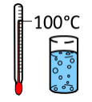 | the action of bringing a liquid to the temperature at which it bubbles and turns to vapour.
Change state  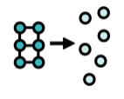 | the process of one state of matter (solid, liquid or gas) changing to another.
Cooling  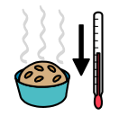 | the action or process of making or becoming less hot or warm.
Freezing  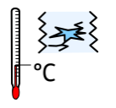 | When a liquid turns into a solid
Gases  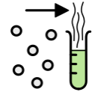 | Do not have a fixed shape and can spread out to completely fill the container or room they are in.
Heating  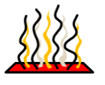 | the process of making something warm
Liquids  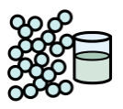 | Liquids take the shape of their container. They can flow or be poured
Melting   | When a solid changes to a liquid
Solids  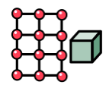 | Materials that keep their shape, unless a force is applied to it.

What should I already know?
Distinguish between an object and the material from which it is made. (Y1 - Everyday materials)
• Identify and name a variety of everyday materials, including wood, plastic, glass, metal, water, and rock. (Y1 - Everyday materials)
• Describe the simple physical properties of a variety of everyday materials. (Y1 - Everyday materials)
• Compare and group together a variety of everyday materials on the basis of their simple physical properties. (Y1 - Everyday materials)
• Identify and compare the suitability of a variety of everyday materials, including wood, metal, plastic, glass, brick, rock, paper and cardboard for particular uses. (Y2 - Uses of everyday materials)
• Find out how the shapes of solid objects made from some materials can be changed by squashing, bending, twisting and stretching. (Y2 - Uses of everyday materials)

Scientific knowledge:

- compare and group materials together, according to whether they are solids, liquids or gases

- observe that some materials change state when they are heated or cooled, and measure or research the temperature at which this happens in degrees Celsius

Teaching Sequence

- To justify why something is a solid, liquid or gas.
- To investigate gases and explain their properties
- To give examples of things that melt/freeze and how their melting points vary
- To measure temperatures using a thermometer (TAPS)

Blooms Taxonomy – Specific Verbs to Use in Lesson Aims
Knowledge: Describe, find, identify, list, locate, name, recognise, retrieve Comprehension: Classify, compare, explain, infer, interpret, paraphrase, summarise Application: Carry out, implement, use Analysis: Deconstruct, Organise, outline, structure Synthesis: Construct, design, devise, invent, make, plan, produce, Evaluation: Appraise, assess, choose,

Term 2 | Let’s Talk (Explorify) | Scientific Knowledge | Scientific skill
Lesson 1 | The odd one out https://explorify.uk/en/activities/odd-one-out/gas | to justify why something is a solid, liquid or gas | To observe
Lesson 2 | What if?  https://explorify.uk/en/activities/what-if/we-used-machines-like-this | to investigate gases and explain their properties | Ask Q’s and Plan Enquiry
Lesson 3 | Have you ever?  Have you ever held a piece of chocolate in your hand?  https://explorify.uk/en/activities/have-you-ever/held-a-piece-of-chocolate-tightly-in-your-hand | to give examples of things that melt/freeze and how their melting points vary | To Record
Lesson 4 | Odd one out  https://explorify.uk/en/activities/odd-one-out/where-is-the-water | to measure temperatures using a thermometer ( TAPS) | To Record

