Key Vocabulary and Definitions:

Input   | a place where, or a device through  which, energy or information enters a system
Audio   | a sound, especially when recorded, transmitted, or reproduced
Device   | a piece of equipment or a mechanism designed to serve a special purpose or perform a special function
Record   | convert (sound or a performance)  into a permanent form for a  broadcast
Soundwave  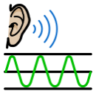 | the pattern of disturbance caused by the movement of energy traveling through a medium (such as air, water  or any other liquid or solid matter)  as it propagates away from the  source of the sound
Sound   | vibrations that travel through the air or another medium and can be heard  when they reach a person's or  animal's ear.
Podcast   | a digital audio file made available on  the internet for downloading to a computer or mobile device
Edit  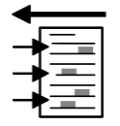 | a change or correction made as a  result of editing.
Trim   | make (something) neat or of the required size or form by cutting  away irregular or unwanted parts.

Progression
- This unit progresses students’ knowledge and understanding of creating media, by focusing on the recording and editing of sound to produce a podcast. Following this unit, learners will explore combining audio with video in the ‘Video editing’ unit in Year 5.

Computing Skills:
● Use search technologies effectively, appreciate how results are selected and ranked, and be discerning in evaluating digital content
● Select, use, and combine a variety of software (including internet services) on a range of digital devices to design and create a range of programs, systems, and content that accomplish given goals, including collecting, analysing, evaluating, and presenting data and information
● Use technology safely, respectfully, and responsibly; recognise acceptable/unacceptable behaviour; identify a range of ways to report concerns about content and contact

Online safety - Health, well-being and lifestyle
- I can explain how using technology can be a distraction from other things, in both a positive and negative way.
- I can identify times or situations when someone may need to limit the amount of time they use technology e.g. I can suggest strategies to help with limiting this time.

Teaching Sequence

- To identify that sound can be recorded
- To explain that audio recordings can be edited
- To recognise the different parts of creating a podcast project
- To apply audio editing skills independently
- To combine audio to enhance my podcast project
- To evaluate the effective use of audio
Online safety
- To explain how using technology can be a distraction from other things, in both a positive and negative way. ( 2 lessons)
- To identify times or situations when someone may need to limit the amount of time, they use technology ( 2 lessons)
- To suggest strategies to help with limiting this time.

Blooms Taxonomy – Specific Verbs to Use in Lesson Aims
Knowledge: Describe, find, identify, list, locate, name, recognise, retrieve Comprehension: Classify, compare, explain, infer, interpret, paraphrase, summarise Application: Carry out, implement, use Analysis: Deconstruct, Organise, outline, structure Synthesis: Construct, design, devise, invent, make, plan, produce, Evaluation: Appraise, assess, choose,

Final outcome
By the end of the term, the children are going to be able to create a podcast . this will include an intro, main content and outro sections in the plan. The children will use the Garageband app to edit and trim the sounds made by the musical instruments made from recycled materials in the Science sessions.

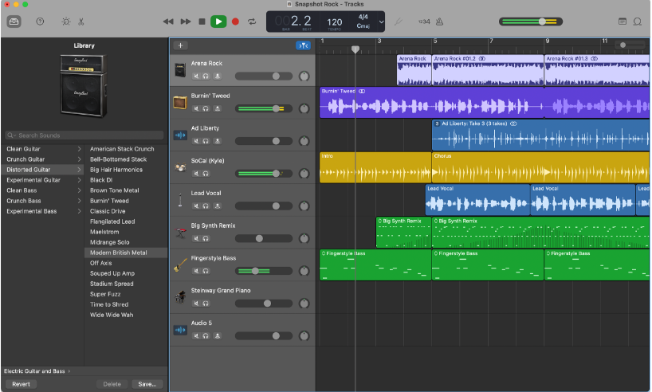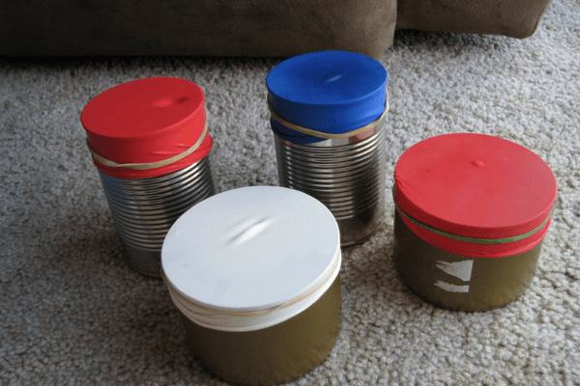
Online safety

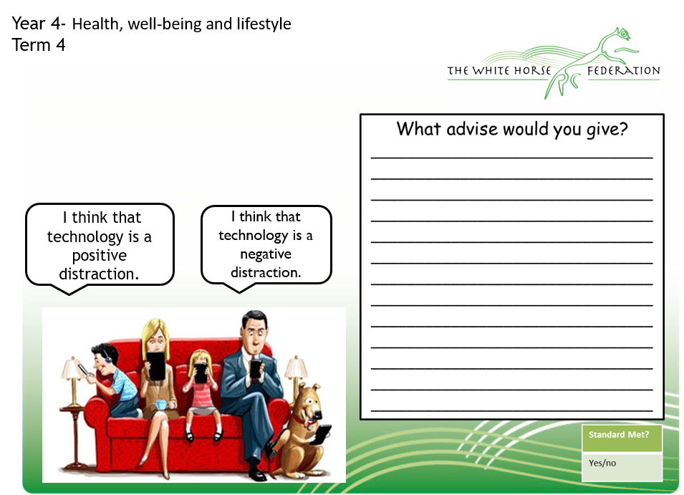

Online Safety - Lessons | Would advise would you give?
1.Aim: To explain how using technology can be a distraction from other things, in both a positive and negative way.
2. Aim: To explain how using technology can be a distraction from other things, in both a positive and negative way.
3. Aim: To identify times or situations when someone may need to limit the amount of time, they use technology
4. Aim: To identify times or situations when someone may need to limit the amount of time, they use technology
5. Aim: To suggest strategies to help with limiting this time.

