Technical Knowledge and skills:
- Threading needles with some help.
- Tying knots with some help.
- Learning basic stitches.
- think about user and aesthetics when choosing textiles
- think of a range of ways to join things
- To begin to understand that a single 3D textiles project can be made from a combination of fabric shapes.
What should I already know?
Investigate and evaluate the existing products to understand their purpose. Discus the given design brief. As a class, create their design criteria. Design their own product using labelled drawings. List all the resources that they require for the product.
Based on their individual designs, choose from a variety of materials and perform practical skills e.g measuring, cutting joining and finishing the product independently.
Testing their products.
Evaluate their ideas and products against the design criteria using a given sheet with leading questions.

Key Vocabulary:

Binca  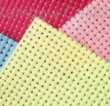 | A form of embroidery canvas that is woven in groups of threads, rather than individual threads.
Applique’  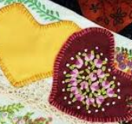 | Ornamental needlework in which pieces of fabric are sewn or stuck on to a larger piece to form a picture or pattern.
Cross stitch  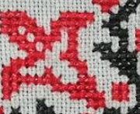 | A stitch formed of two stitches crossing each other.
Sew  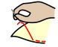 | Join, fasten, or repair (something) by making stitches with a needle and thread.
Template  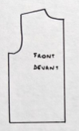 | A form, mold or pattern used as a guide to make something.

DT Skills:
Investigate and analyse the existing products that they have researched in small groups to understand their purpose. Discus the given design brief. As a class, create their design criteria.
Design their own product using labelled drawings and CAD (PurpleMash). List all the resources that they require for the product.
Based on their individual designs, choose from a variety of materials and perform practical skills e.g measuring, cutting joining and finishing the product independently with some accuracy.
Testing their products.
Evaluate their ideas and products against the design criteria using a given sheet with leading questions.

Blooms Taxonomy – Specific Verbs to Use in Lesson Aims
Knowledge: Describe, find, identify, list, locate, name, recognise, retrieve Comprehension: Classify, compare, explain, infer, interpret, paraphrase, summarise Application: Carry out, implement, use Analysis: Deconstruct, Organise, outline, structure Synthesis: Construct, design, devise, invent, make, plan, produce, Evaluation: Appraise, assess, choose,

Focused designer/ company
Coco Chanel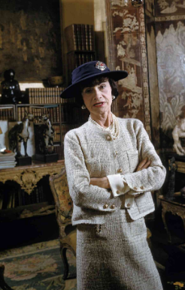

Key Knowledge

Cross Stitch

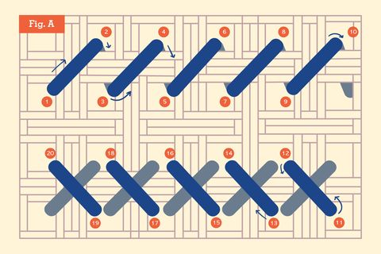

Appliqué​

