Key Vocabulary and Definitions:

Capital city  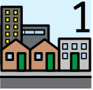 | A capital is a city where a region's government is located.
Climate  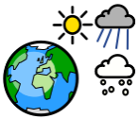 | Climate is the long-term pattern of weather in a particular area.
Continent  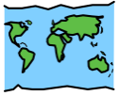 | A continent is one of Earth's seven main divisions of land.
Digital Map  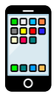 | A map accessed using an internet device.
Human  Geography  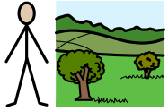 | Features of land that have been impacted by human activity
Landmark   | A building or feature which is easily recognised.
Location  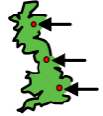 | A particular place or position.
Physical geography  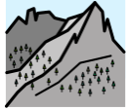 | Natural features of land e.g. mountains
Population  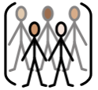 | The amount of people who live in one area or country

What should I already know?
- Use maps, atlases, globes and digital/computer mapping (Google Earth) to locate countries and describe features studied.
- Describe and understand key aspects of: Physical geography including key topographical features (inc. hills, mountains, coasts, rivers).

Geography Skills:
- Locate the world’s countries, using maps to focus on Europe (inc. the location of Russia) and North and South America, concentrating on their environmental regions, key physical and human characteristics, countries and other major cities.
- Use maps, atlases, globes and digital/computer mapping (Google Earth) to locate countries and describe features.
- Understand geographical similarities and differences through studying the human and physical geography of a region in the United Kingdom and region in a European country.

Teaching Sequence

1. To locate countries and capital cities on a world map.
2. To use a variety of sources to identify human and physical features.
3. To use digital mapping to describe and locate Parisian tourist attractions.
4. To use digital mapping to describe and locate tourist attractions in London.

5. To compare and contrast London and Paris.
Blooms Taxonomy – Specific Verbs to Use in Lesson Aims
Knowledge: Describe, find, identify, list, locate, name, recognise, retrieve Comprehension: Classify, compare, explain, infer, interpret, paraphrase, summarise Application: Carry out, implement, use Analysis: Deconstruct, Organise, outline, structure Synthesis: Construct, design, devise, invent, make, plan, produce, Evaluation: Appraise, assess, choose,

Key Knowledge

