Key Vocabulary and Definitions:

Pitch  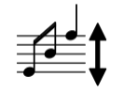 | how low or high a tone is.
Source  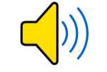 | a musical instrument, a human voice, a computer, an animal, the wind, or anything else that can produce sound.
Travel  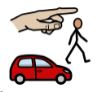 | (of an object or radiation) move, typically in a constant or predictable way.
Insulation   | the process of keeping heat, sound, or electricity from spreading.
Faint  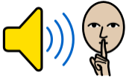 | A sound which is barely noticed
Loud 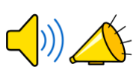 | producing or capable of producing much noise
Vibrate  | move continuously and rapidly to and fro.
Vibration  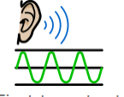 | a movement backwards and forwards
Volume  | The loudness of a sound.

What should I already know?
Uses of everyday materials
-identify and compare the suitability of a variety of everyday materials, including wood, metal, plastic, glass, brick, rock, paper, and cardboard for particular uses
-find out how the shapes of solid objects made from some materials can be changed by squashing, bending, twisting, and stretching

Science knowledge :
- identify how sounds are made, associating some of them with something vibrating
- recognise that vibrations from sounds travel through a medium to the ear
- find patterns between the pitch of a sound and features of the object that produced it
- find patterns between the volume of a sound and the strength of the vibrations that produced it
- recognise that sounds get fainter as the distance from the sound source increases

Blooms Taxonomy – Specific Verbs to Use in Lesson Aims
Knowledge: Describe, find, identify, list, locate, name, recognise, retrieve Comprehension: Classify, compare, explain, infer, interpret, paraphrase, summarise Application: Carry out, implement, use Analysis: Deconstruct, Organise, outline, structure Synthesis: Construct, design, devise, invent, make, plan, produce, Evaluation: Appraise, assess, choose,
Teaching Sequence

1. To classify sound sources
2. To explore making sounds with a range of objects, such as musical instruments and other household objects
(TAPS)
3. To explore how string telephones work (TAPS)
4. To understand how to alter the pitch or volume of objects
5. To measure sounds over different distances
6. To measure sounds through different insulation materials

Scientific Skills
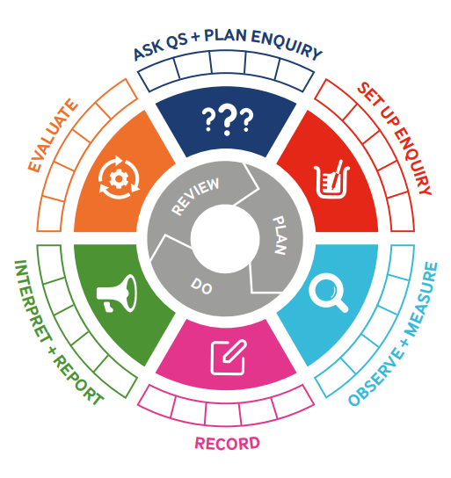
Term 3 | Let’s Talk (Explorify) | Scientific Knowledge | Scientific skill
Lesson 1 | WHAT'S GOING ON?  The sound of silence  https://explorify.uk/en/activities/whats-going-on/the-sound-of-silence | To classify sound sources | To observe
Lesson 2 | WHAT'S GOING ON?  https://explorify.uk/en/activities/whats-going-on/pitch-perfect | To explore making sounds with a range of objects, such as musical instruments and other household objects ( TAPS) | Ask Q’s and Plan Enquiry
Lesson 3 | LISTEN, WHAT CAN YOU HEAR?  Keeping track  https://explorify.uk/en/activities/listen-what-can-you-hear/keeping-track | To explore how string telephones work (TAPS) | Ask Q’s and Plan Enquiry
Lesson 4 | LISTEN, WHAT CAN YOU HEAR? Musical beats  https://explorify.uk/en/activities/listen-what-can-you-hear/musical-beats | To understand how to alter the pitch or volume of objects | To Observe
Lesson 5 | WHAT IF...  https://explorify.uk/en/activities/what-if/you-could-hear-every-sound-at-equal-volume | To measure sounds over different distances | To Record
Lesson 6 |   https://explorify.uk/en/activities/have-you-ever/heard-your-neighbours-in-the-next-house-or-flat | To measure sounds through different insulation materials | To record

