Key Vocabulary:

|  |  |
| --- | --- |
| Accordion | It is made out of a straight line that's set at an angle instead of straight up or across. |
| Illustration | It is a straight line that is drawn from left to right or right to left. |
| Sequences | It is a pattern or image made of small regular or irregular pieces of coloured stone, glass or ceramic, held in place by plaster/mortar, and covering a surface. |
| Medium | Three dimensional, refers to the three spatial dimensions of width, height and depth. |
| Storytelling | To become or make larger or more extensive. |
| Atmosphere | It is an artistic form in which hard or plastic materials are worked into three-dimensional art objects. |

What should I already know?

(Substantive Knowledge)

* Understand that artists and illustrators interpret narrative texts and create sequenced drawings.
* Understand that still life name given to the genre of painting (or making) a collection of objects/elements.
* Understand that artists use sketchbooks for different purposes and that each artist will find their own ways of working in a sketchbook.
* Understand we may all have different responses in terms of our thoughts and the things we make. That we may share similarities.
* Understand all responses are valid.

What will I learn?

(Implicit Knowledge/Skills)

* Practice drawing skills.
* Make visual notes to record ideas and processes discovered through looking at other artists.
* Test and experiment with materials.
* Create owned narratives by arranging toys in staged scenes, using these as subject matter to explore creation of drawings using charcoal and chalk which convey drama and mood. Use light and portray light/shadow.
* Interpret poetry or prose and create sequenced images in either an accordian or poetry comic format. Work in a variety of media according to intention, including handwriting pen, graphite or ink.
* Document work using still image (photography) or by making a drawing of the work. If using photography consider lighting and focus. Some children may make films thinking about viewpoint, lighting & perspective.

Focus Artists

Lara Carlin, Shauna Tan

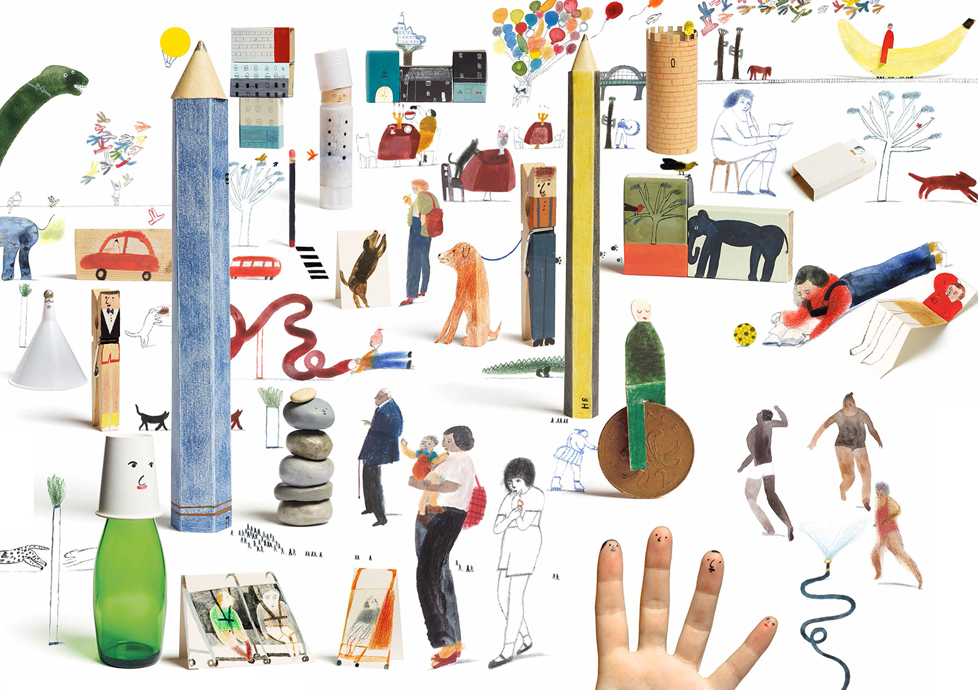 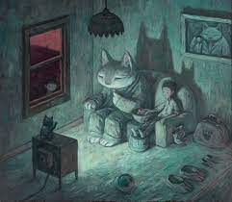

And Cressida Cowell

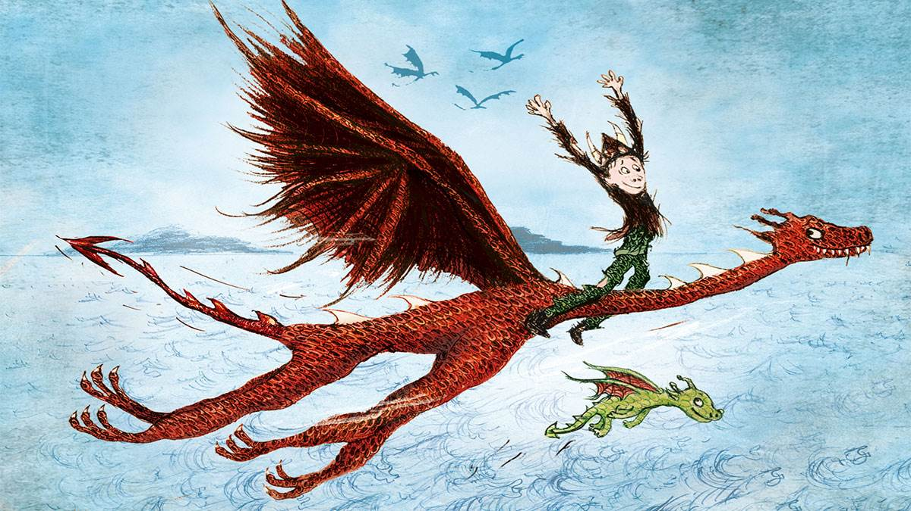

Blooms Taxonomy – Specific Verbs to Use in Lesson Aims

Knowledge: Describe, find, identify, list, locate, name, recognise, retrieve Comprehension: Classify, compare, explain, infer, interpret, paraphrase, summarise Application: Carry out, implement, use Analysis: Deconstruct, Organise, outline, structure Synthesis: Construct, design, devise, invent, make, plan, produce, Evaluation: Appraise, assess, choose,

Glue here.

My Learning Ladder

|  |  |  |  |
| --- | --- | --- | --- |
| Learning Objective | | Pupil Voice | Teacher Assessment |
| to discuss the work of Laura Carlin and Shaun Tan | |  |  |
| to experiment drawing stories | |  |  |
| to explore illustration techniques by Cressida Cowell | |  |  |
| to draw the story of Wisp- The Story of Hope | |  |  |
| to finalise my drawing of Wisp- The Story of Hope | |  |
| to evaluate my Wisp- The Story of Hope drawing | | See below. |  |
| Evaluation of my Final Piece | | | |
|  |  | | |
|  |  | | |
|  |  | | |