Progression
This unit progresses learners’ knowledge and understanding of data and how it can be collected over time to answer questions. Specifically, it builds on the concept of answering questions with data which is first introduced in the KS1 data and information units as well as idea of automatic data collection.

Key Vocabulary and Definitions:
Layout | The process of calculating the  position of objects in space  subject to various constraints.
Input  | The information entered into a computer  System.
Device | A complete piece of physical  hardware that is used to support  computer functions within a larger  system.
Sensor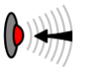 | A device, module, machine or  Subsystem that detects events or  changes.
Logging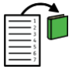 | Keeping a log of events that occur  within a computer system.
Data point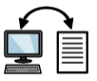 | A single piece of information or  observation that presents a  specific value or characteristic.
Interval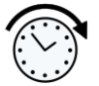 | A data type that is measured along  a scale, in which each point is  placed at equal distances from one  another.
Analyse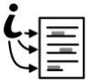 | To look at information.
Dataset | A collection of data (information).
import | The process of bringing external  information to a device.

Computing Skills:
In this unit, learners will collect data as well as access data captured over long periods of time. They will look at data points, data sets, and logging intervals. Learners will spend time using a computer to review and analyse data. Towards the end of the unit, learners will pose questions and then use data loggers to automatically collect the data needed to answer those questions.
Online Safety:
- Disinformation and why individuals or groups choose to share false information to deliberately deceive.
- Misinformation and being aware that false and misleading information can be shared inadvertently.
- Misinformation and understanding that some genuine information can be published with the deliberate intent to harm, for example releasing private information or photographs (including revenge porn)
- Online hoaxes, which can be deliberately and inadvertently spread for a variety of reasons.
- Explaining that the viral nature of this sort of content can often appear to be a stamp of authenticity and therefore why it is important to evaluate what is seen online.
- How to measure and check authenticity online
- The potential consequences of sharing information that may not be true.

Teaching Sequence

- To explain that data gathered over time can be used to answer questions.
- To use a digital device to collect data automatically.
- To explain that a data logger collects ‘data points’ from sensors over time.
- To recognise how a computer can help us analyse data.
- To identify the data needed to answer questions.
- To use data from sensors to answer questions.

Online safety-Managing online information
- To analyse information to make a judgement about probable accuracy.
- To describe how to search for information within a wide group of technologies and make a judgement about the probable accuracy.
- To describe some of the methods used to encourage people to buy things.
- To explain why lots of people sharing the same opinions or beliefs online do not make those opinions or beliefs true.
Blooms Taxonomy – Specific Verbs to Use in Lesson Aims
Knowledge: Describe, find, identify, list, locate, name, recognise, retrieve Comprehension: Classify, compare, explain, infer, interpret, paraphrase, summarise Application: Carry out, implement, use Analysis: Deconstruct, Organise, outline, structure Synthesis: Construct, design, devise, invent, make, plan, produce, Evaluation: Appraise, assess, choose,

Progression
This unit progresses learners’ knowledge and understanding of data and how it can be collected over time to answer questions. Specifically, it builds on the concept of answering questions with data which is first introduced in the KS1 data and information units as well as idea of automatic data collection.

Key Vocabulary and Definitions:
Layout | The process of calculating the  position of objects in space  subject to various constraints.
Input | The information entered into a computer  System.
Device | A complete piece of physical  hardware that is used to support  computer functions within a larger  system.
Sensor | A device, module, machine or  Subsystem that detects events or  changes.
Logging | Keeping a log of events that occur  within a computer system.
Data point | A single piece of information or  observation that presents a  specific value or characteristic.
Interval | A data type that is measured along  a scale, in which each point is  placed at equal distances from one  another.
Analyse | To look at information.
Dataset | A collection of data (information).
import | The process of bringing external  information to a device.

Computing Skills:
In this unit, learners will collect data as well as access data captured over long periods of time. They will look at data points, data sets, and logging intervals. Learners will spend time using a computer to review and analyse data. Towards the end of the unit, learners will pose questions and then use data loggers to automatically collect the data needed to answer those questions.
Online Safety:
- Disinformation and why individuals or groups choose to share false information to deliberately deceive.
- Misinformation and being aware that false and misleading information can be shared inadvertently.
- Misinformation and understanding that some genuine information can be published with the deliberate intent to harm, for example releasing private information or photographs (including revenge porn)
- Online hoaxes, which can be deliberately and inadvertently spread for a variety of reasons.
- Explaining that the viral nature of this sort of content can often appear to be a stamp of authenticity and therefore why it is important to evaluate what is seen online.
- How to measure and check authenticity online
- The potential consequences of sharing information that may not be true.

Teaching Sequence

- To explain that data gathered over time can be used to answer questions.
- To use a digital device to collect data automatically.
- To explain that a data logger collects ‘data points’ from sensors over time.
- To recognise how a computer can help us analyse data.
- To identify the data needed to answer questions.
- To use data from sensors to answer questions.

Online safety-Managing online information
- To analyse information to make a judgement about probable accuracy.
- To describe how to search for information within a wide group of technologies and make a judgement about the probable accuracy.
- To describe some of the methods used to encourage people to buy things.
- To explain why lots of people sharing the same opinions or beliefs online do not make those opinions or beliefs true.
Blooms Taxonomy – Specific Verbs to Use in Lesson Aims
Knowledge: Describe, find, identify, list, locate, name, recognise, retrieve Comprehension: Classify, compare, explain, infer, interpret, paraphrase, summarise Application: Carry out, implement, use Analysis: Deconstruct, Organise, outline, structure Synthesis: Construct, design, devise, invent, make, plan, produce, Evaluation: Appraise, assess, choose,

Key Knowledge
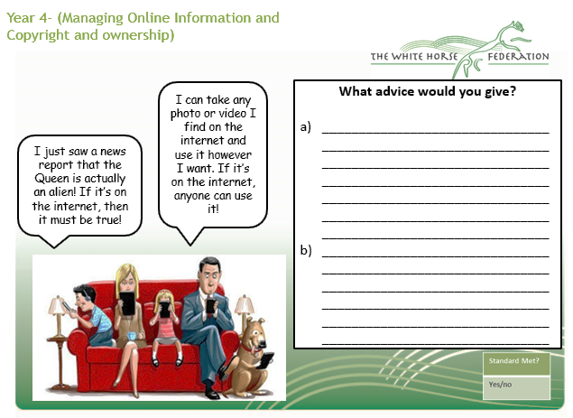

The outcome for of the unit will look similar to the below example, which shows a bar chart about pupils’ favourite subject. Pupils will use the App Easysense 2 to create and present the information.

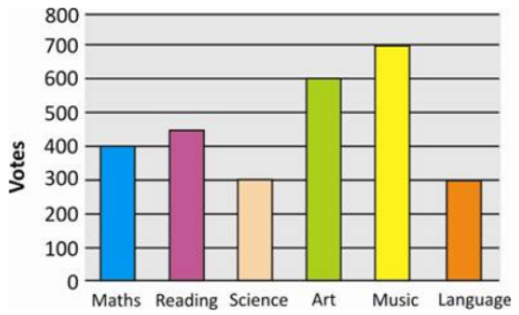

Subject

