What should I already know?

Investigate and evaluate the existing products to understand their purpose. Discus the given design brief. As a class, create their design criteria. Design their own product using labelled drawings. List all the resources that they require for the product.
Based on their individual designs, choose from a variety of materials and perform practical skills e.g measuring, cutting joining and finishing the product independently.
Testing their products.
Evaluate their ideas and products against the design criteria using a given sheet with leading questions.
Technical Knowledge:
To learn about how a simple circuit works.

To use simple circuit in product

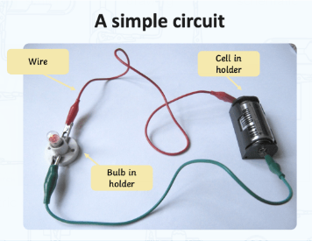

DT Skills:
Investigate and analyse the existing products that they have researched in small groups to understand their purpose. Discus the given design brief. As a class, create their design criteria.
Design their own product using labelled drawings and CAD (PurpleMash). List all the resources that they require for the product.
Based on their individual designs, choose from a variety of materials and perform practical skills e.g measuring, cutting joining and finishing the product independently with some accuracy.
Testing their products.
Evaluate their ideas and products against the design criteria using a given sheet with leading questions.

Key Vocabulary:

Assemble  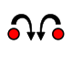 | fit together the separate component parts.
Battery  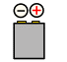 | a container consisting of one or more cells, in which chemical energy is converted into electricity and used as a source of power.
Bulb   | a light bulb.
Product   | any item or service you sell to serve a customer's need or want.
Torch   | a portable battery-powered electric lamp.

Focused inventor
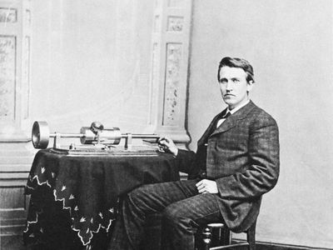
Thomas Edison
Blooms Taxonomy – Specific Verbs to Use in Lesson Aims
Knowledge: Describe, find, identify, list, locate, name, recognise, retrieve Comprehension: Classify, compare, explain, infer, interpret, paraphrase, summarise Application: Carry out, implement, use Analysis: Deconstruct, Organise, outline, structure Synthesis: Construct, design, devise, invent, make, plan, produce, Evaluation: Appraise, assess, choose,

Key Knowledge

Science – electricity
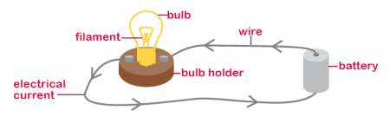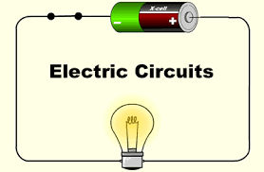

Some real-life examples include:
- Lamps
- Torches

- Final product
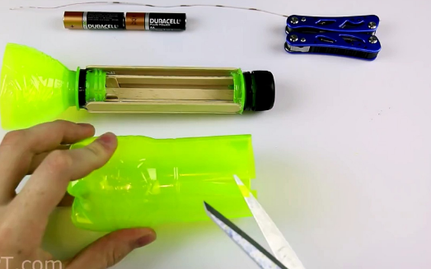

Some real-life examples include:

