What should I already know?
- Learn the eight points of a compass, and four-figure grid references.
- Use fieldwork to observe, measure and record the human and physical features in the local area using a range of methods, including sketch maps, plans and graphs, and digital technologies

Key Vocabulary and Definitions:

City 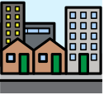 | A large settlement – usually with a cathedral.
Compass 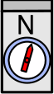 | An instrument to show the direction of north.
Graph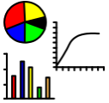 | Drawings that show information with lines, shapes, and colours.
Region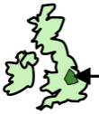 | An area, of a country or the world having common characteristics.
Rural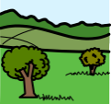 | The countryside.
Settlement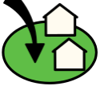 | A place where people create a community.
Survey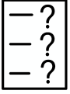 | Collecting data
Town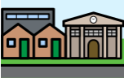 | A built-up area with area, larger than a village.
Village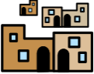 | Small settlement in a rural area

Geography Skills:
- Use fieldwork to observe, measure and record the human and physical features in the local area using a range of methods, including sketch maps, plans and graphs, and digital technology
- To study types of settlements in modern Britain: villages, towns, cities.
- Use the eight points of a compass, four-figure grid references, symbols and key (including the use of Ordnance Survey maps) to build their knowledge of the United Kingdom and the wider world.

Teaching Sequence

- To study different settlements in modern Britain.
- To use an 8-point compass
- To be able to identify a range of mapping symbols and know their meanings.
- To understand and describe how settlements are connected.
- To draw a sketch map of the local area including human and physical features
- To collect data about road use in the local community and plot your fieldwork records into a graph.

Blooms Taxonomy – Specific Verbs to Use in Lesson Aims
Knowledge: Describe, find, identify, list, locate, name, recognise, retrieve Comprehension: Classify, compare, explain, infer, interpret, paraphrase, summarise Application: Carry out, implement, use Analysis: Deconstruct, Organise, outline, structure Synthesis: Construct, design, devise, invent, make, plan, produce, Evaluation: Appraise, assess, choose,

What should I already know?
- Learn the eight points of a compass, and four-figure grid references.
- Use fieldwork to observe, measure and record the human and physical features in the local area using a range of methods, including sketch maps, plans and graphs, and digital technologies

Key Vocabulary and Definitions:

City | A large settlement – usually with a cathedral.
Compass | An instrument to show the direction of north.
Graph | Drawings that show information with lines, shapes, and colours.
Region | An area, of a country or the world having common characteristics.
Rural | The countryside.
Settlement | A place where people create a community.
Survey | Collecting data
Town | A built-up area with area, larger than a village.
Village | Small settlement in a rural area

Geography Skills:
- Use fieldwork to observe, measure and record the human and physical features in the local area using a range of methods, including sketch maps, plans and graphs, and digital technology
- To study types of settlements in modern Britain: villages, towns, cities.
- Use the eight points of a compass, four-figure grid references, symbols and key (including the use of Ordnance Survey maps) to build their knowledge of the United Kingdom and the wider world.

Teaching Sequence

- To study different settlements in modern Britain.
- To use an 8-point compass
- To be able to identify a range of mapping symbols and know their meanings.
- To understand and describe how settlements are connected.
- To draw a sketch map of the local area including human and physical features
- To collect data about road use in the local community and plot your fieldwork records into a graph.

Blooms Taxonomy – Specific Verbs to Use in Lesson Aims
Knowledge: Describe, find, identify, list, locate, name, recognise, retrieve Comprehension: Classify, compare, explain, infer, interpret, paraphrase, summarise Application: Carry out, implement, use Analysis: Deconstruct, Organise, outline, structure Synthesis: Construct, design, devise, invent, make, plan, produce, Evaluation: Appraise, assess, choose,

Key Knowledge

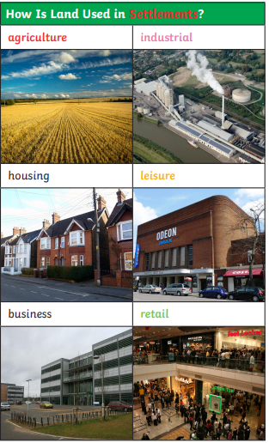

Example of a UK Settlement:
