What should I already know?

* Learn the eight points of a compass, and four-figure grid references.
* Use fieldwork to observe, measure and record the human and physical features in the local area using a range of methods, including sketch maps, plans and graphs, and digital technologies

Key Vocabulary and Definitions:

|  |  |
| --- | --- |
| City | A large settlement – usually with a cathedral. |
| Compass | An instrument to show the direction of north. |
| Graph | Drawings that show information with lines, shapes, and colours. |
| Region | An area, of a country or the world having common characteristics. |
| Rural | The countryside. |
| Settlement | A place where people create a community. |
| Survey | Collecting data |
| Town | A built-up area with area, larger than a village. |
| Village | Small settlement in a rural area |

Geography Skills:

* Use fieldwork to observe, measure and record the human and physical features in the local area using a range of methods, including sketch maps, plans and graphs, and digital technology
* To study types of settlements in modern Britain: villages, towns, cities.
* Use the eight points of a compass, four-figure grid references, symbols and key (including the use of Ordnance Survey maps) to build their knowledge of the United Kingdom and the wider world.

Teaching Sequence

1. To study different settlements in modern Britain.
2. To use an 8-point compass
3. To be able to identify a range of mapping symbols and know their meanings.
4. To understand and describe how settlements are connected.
5. To draw a sketch map of the local area including human and physical features
6. To collect data about road use in the local community and plot your fieldwork records into a graph.

Blooms Taxonomy – Specific Verbs to Use in Lesson Aims

Knowledge: Describe, find, identify, list, locate, name, recognise, retrieve Comprehension: Classify, compare, explain, infer, interpret, paraphrase, summarise Application: Carry out, implement, use Analysis: Deconstruct, Organise, outline, structure Synthesis: Construct, design, devise, invent, make, plan, produce, Evaluation: Appraise, assess, choose,

Key Knowledge

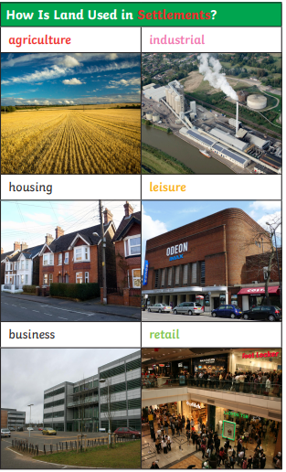

Example of a UK Settlement:

