Key Vocabulary and Definitions:

Biome | 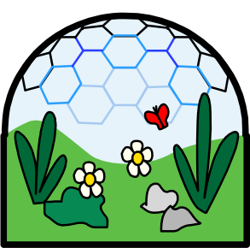 | Areas of our planet with similar climates, landscapes, animals and plants
Climate | 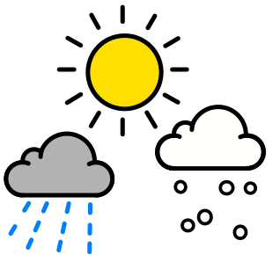 | The average weather conditions in an area over a period of time
Equator | 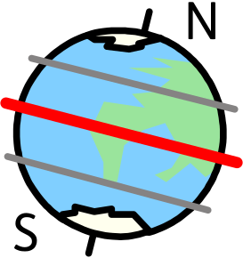 | The imaginary line that circles around the earth at 0º longitude
hemisphere | 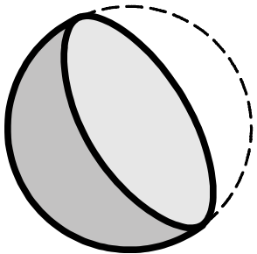 | Half a sphere
Human geography |  | Something that is built by humans and would not have existed in nature without humans.
Landmark |  | A recognizable building or object that can be seen from a distance
Latitude | 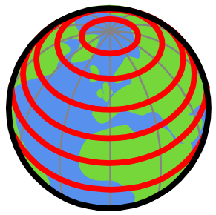 | Imaginary lines that circle horizontally around the earth
Longitude | 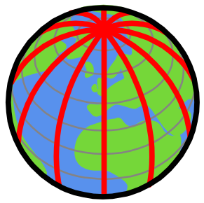 | Imaginary lines that circle vertically around the earth
Physical geography |  | The study of the Earth's natural features, such as mountains, rivers, deserts and oceans.
Weather |  | The daily weather (rain, dry, cloudy, sunny, hot, cold)

What should I already know?
- Name and locate the world’s seven continents and five oceans
- Identify seasonal and daily weather patterns in the United Kingdom and the location of hot and cold areas of the world in relation to the Equator and the North and South Poles

Geographical Skills:
- Locate the main countries in Europe and North or South America.
- Identify the position and significance of latitude/longitude and the Greenwich Meridian.
- Linking with science, time zones, night and day (term 4 Science)
- Physical geography including climate zones and biomes
- Use maps, atlases, globes and digital/computer mapping (Google Earth) to locate countries.

Teaching Sequence
- To locate the countries and key features of North America
- To explain the location of places in North America using geographical terminology.

- To describe how physical and human processes have shaped North America’s landscapes.
- To explain how climate influences biomes, settlements and human activity.
- To investigate the geographical significance of the Great Lakes and Niagara Falls.
- To compare the physical and human geography of two contrasting lake landscapes.

Blooms Taxonomy – Specific Verbs to Use in Lesson Aims
Knowledge: Describe, find, identify, list, locate, name, recognise, retrieve Comprehension: Classify, compare, explain, infer, interpret, paraphrase, summarise Application: Carry out, implement, use Analysis: Deconstruct, Organise, outline, structure Synthesis: Construct, design, devise, invent, make, plan, produce, Evaluation: Appraise, assess, choose,

Key Knowledge
