Key Vocabulary and Definitions:

Crucifixion   | Being put to death by being nailed to a cross.
Disciples  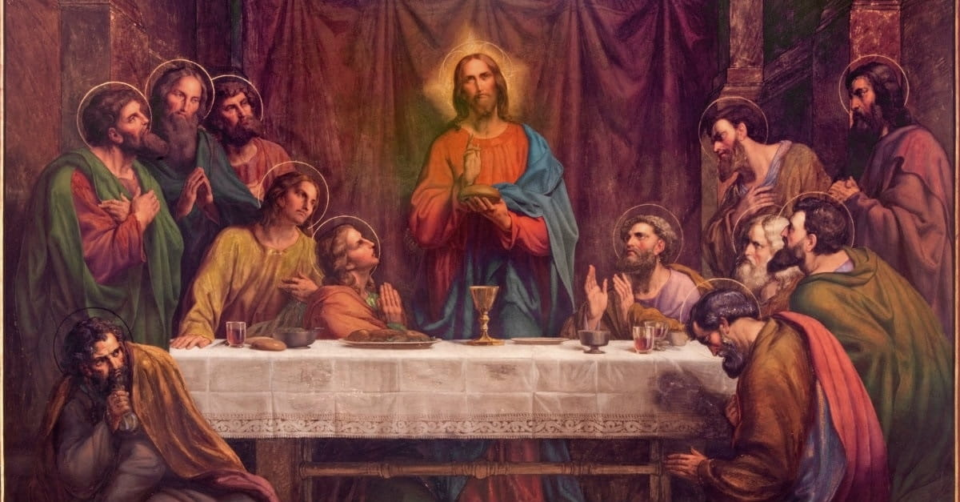 | Jesus’ original 12 followers.
Holy Week  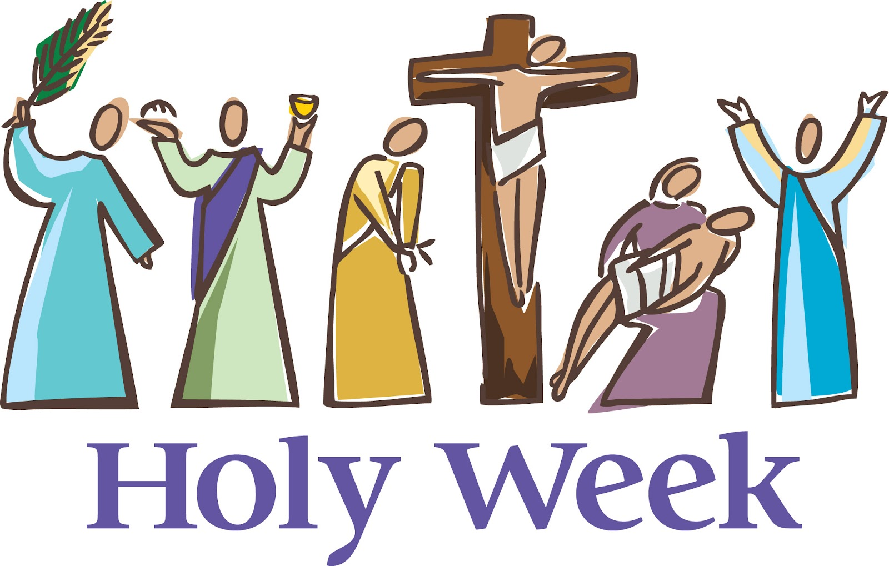 | The week leading up to Easter to remember the last week of Jesus's life. Holy Week begins on Palm Sunday.
Incarnation  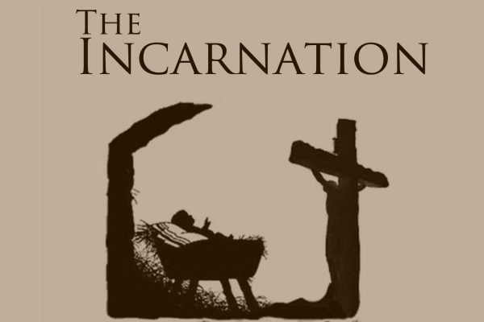 | God becoming man or literally being “made flesh”. Jesus was God incarnate.
Pharisee   | A strictly orthodox Jew who adhered closely to the rules and scriptures.
Pontius Pilate  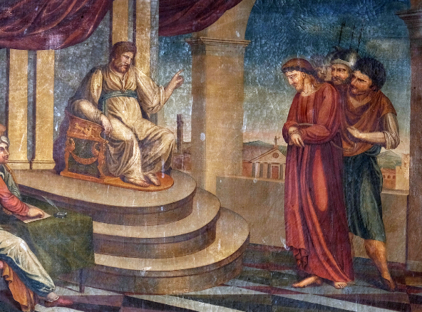 | The Roman governor of the region of Judaea.
Pre-destination  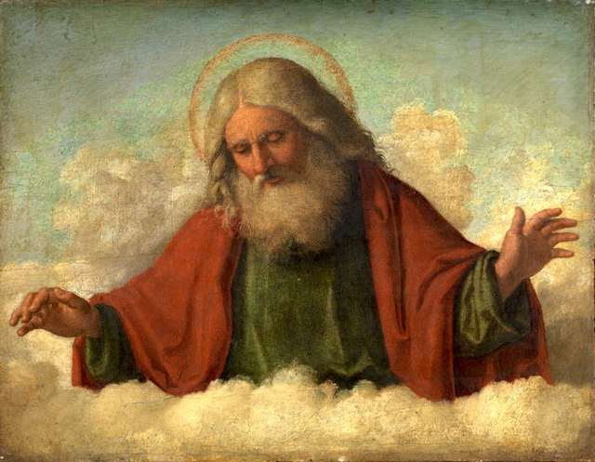 | The belief that everything that happens has already been determined by God.
Resurrection  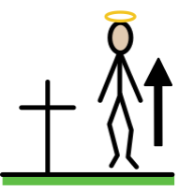 | Coming back to life after being put to death.
Tomb   | A large vault used for burying the dead.

What should I already know?
- Builds on all previous Easter enquiries which details Jesus’ actions in the temple.
- Christians believe that Jesus selflessly gave himself for their salvation.

RE Skills:
- Give an example of someone with a strong sense of purpose for their life and give my opinions on this.
- Explain whether God intended Jesus to be crucified or whether Jesus’ crucifixion was the consequence of events during Holy Week.
- Express my opinion about Jesus’ crucifixion being his destiny/purpose.

Blooms Taxonomy – Specific Verbs to Use in Lesson Aims
Knowledge: Describe, find, identify, list, locate, name, recognise, retrieve Comprehension: Classify, compare, explain, infer, interpret, paraphrase, summarise Application: Carry out, implement, use Analysis: Deconstruct, Organise, outline, structure Synthesis: Construct, design, devise, invent, make, plan, produce, Evaluation: Appraise, assess, choose,

Teaching Sequence

- To understand how some people believe in destiny and others might believe in having free will to make their own choices’
- To consider whether the crucifixion was a consequence of the events of Holy Week (3 lessons)
- To explain whether the evidence shows that God intended Jesus to be crucified and rise again or it was a consequence of the events of Holy Week
- To give an example of someone with a strong sence of purpose in their life.

Key Knowledge

