Key Vocabulary and Definitions:
Battle  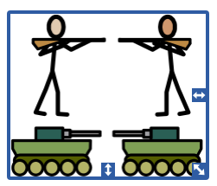 | A large fight between groups of people with opposing views.
House of Lancaster  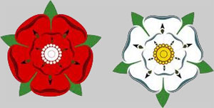 | A family title, like a surname (red rose).
House of York | A family title, like a surname (white rose).
King  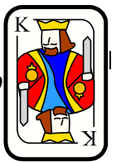 | A male ruler of a country, who inherits the position from family.
Medieval  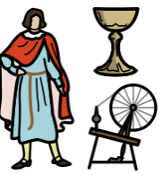 | The ‘Middle Ages’ of history from around 600ad to around 1500ad.
Monarch  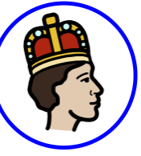 | A male or female ruler of a country.
Peasant  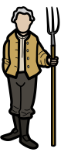 | A poor person of low social status, who usually does physical work
Playwright 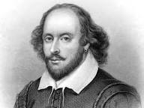 | A person who writes plays
Voyage  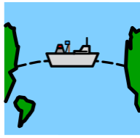 | A long journey, travelling by sea.

What should I already know?
- Key Tudor events such as the Plague and the Great Fire of London.
- Know about the lives of some significant individuals
- Be able to order dates chronologically

History Skills:
- Use relevant terms and periods labels.
- Examine causes and results of great events and the impact on people.
- Study different aspects of life of different people – differences between men and women.
- Use evidence to build up a picture of life in time studied. Select relevant sections of information.
- Compare accounts of events from different sources Fact or fiction.
- Select relevant sections of information.

Blooms Taxonomy – Specific Verbs to Use in Lesson Aims
Knowledge: Describe, find, identify, list, locate, name, recognise, retrieve Comprehension: Classify, compare, explain, infer, interpret, paraphrase, summarise Application: Carry out, implement, use Analysis: Deconstruct, Organise, outline, structure Synthesis: Construct, design, devise, invent, make, plan, produce, Evaluation: Appraise, assess, choose,

Teaching Sequence
- To identify how the Tudors came into power.
- To use evidence to describe different aspects of life between rich and poor Tudors.
- To discover what changes Tudor exploration brought to England during Elizabeth I reign.
- To explain the consequences of being a witch in Tudor England
- To explain the significant impact William Shakespeare has had on modern entertainment and language.

Enquiry Question: How far did The Tudors change Britain?

Disciplinary Knowledge/Skills, Lesson Enquiries and Success Criteria:

- Causes: How did the Tudors come into power?
- To explain what happened during the Battle of Bosworth.
- To give a clear explanation of why The House of Lancaster and the House of York were fighting.

- Evidence: What was life like for Tudors?
- To spot the difference between reliable evidence and ideas we’re not sure about.
- To explain what evidence teaches us about real Tudor people (rich/poor).

- Continuity and Change: How did exploration change during Elizabeth’s reign?
- To identify the countries/routes explored by Tudors.
- To explain what the explorers found and how that changed life for Tudor people (food/spices/silk/gold)

- Consequence: Who could be accused of Witchcraft in the Tudor times?
  - To identify who could be accused of witchcraft in the Tudor Times
  - To explain the punishments for witches

- Significance: Who was William Shakespeare?
  - To identify who Shakespeare was and why he is so famous
  - To explain the significant impact Shakespeare has had on modern entertainment and language

