Key Vocabulary and Definitions:

Air resistance | 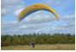 | Air pushes against an object to slow it down.
Buoyancy | 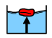 | The ability of an object to float on water.
Friction | 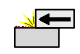 | The action of one surface or object rubbing against another.
Gravity | 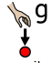 | The force that attracts an object towards the centre of the Earth.
Mass | 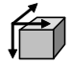 | Mass is the measure of the amount of matter (stuff) in an object - measured in grams (g) or kilograms (kg).
Newtons |  | The unit of measurement used when weighing the force of gravity acting on an object.
Newton meter | 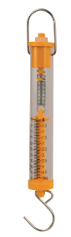 | (also called a force meter) measures an object’s weight.
Water resistance |  | Water pushes against an object to slow it down.
Weight | 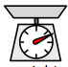 | In science, weight is the force of gravity acting on an object and is measured in Newtons (N).

What should I already know?
- Compare how things move on different surfaces. (Y3 - Forces and magnets)
- Notice that some forces need contact between two objects, but magnetic forces can act at a distance. (Y3 - Forces and magnets)
- Observe how magnets attract or repel each other and attract some materials and not others. (Y3 - Forces and magnets)
- Compare and group together a variety of everyday materials on the basis of whether they are attracted to a magnet, and identify some magnetic materials. (Y3 - Forces and magnets)
- Describe magnets as having two poles. (Y3 - Forces and magnets)
- Predict whether two magnets will attract or repel each other, depending on which poles are facing. (Y3 - Forces and magnets)

Scientific Knowledge:
- Explain that unsupported objects fall towards the Earth because of the force of gravity acting between the Earth and the falling object.
- Identify the effects of air resistance, water resistance and friction that act between moving surfaces.
- Recognise that some mechanisms, including levers, pulleys and gears, allow a smaller force to have a greater effect.

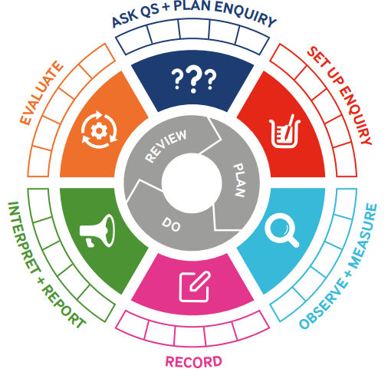

Teaching Sequence
- To identify forces acting on objects.

- To explore the effect that gravity has on objects.

- To identify they effects of friction acting between two moving surfaces.

- To identify and explain the effects of air resistance.

- To compare how water resistance acts on different shapes. (TAPs assessment)

- To recognise that leavers, pulleys and gears allow a smaller force to have a greater effect.

Blooms Taxonomy – Specific Verbs to Use in Lesson Aims
Knowledge: Describe, find, identify, list, locate, name, recognise, retrieve Comprehension: Classify, compare, explain, infer, interpret, paraphrase, summarise Application: Carry out, implement, use Analysis: Deconstruct, Organise, outline, structure Synthesis: Construct, design, devise, invent, make, plan, produce, Evaluation: Appraise, assess, choose,

Scientific Skills

Term 4 | Let’s Talk (Explorify) | Scientific Knowledge | Scientific skill
Lesson 1 | Have you ever…Tried to keep a balloon in the air?  https://explorify.uk/en/activities/have-you-ever/tried-to-keep-a-balloon-in-the-air | Explain that unsupported objects fall towards the Earth because of the force of gravity acting between the Earth and the falling object. | Observe and record
Lesson 2 | Have you ever warmed your hands by rubbing them?  https://explorify.uk/en/activities/have-you-ever/warmed-your-hands-by-rubbing-them | Identify the effects of air resistance, water resistance and friction that act between moving surfaces | Set up and enquiry  Evaluate
Lesson 3 | Odd one out – blowing in the wind  https://explorify.uk/en/activities/odd-one-out/blowing-in-the-wind | Identify the effects of air resistance, water resistance and friction that act between moving surfaces | Set up and enquiry  Evaluate
Lesson 4 | Have you ever tried running through water?  https://explorify.uk/en/activities/have-you-ever/tried-running-through-water | Identify the effects of air resistance, water resistance and friction that act between moving surfaces | Set up and enquiry  Evaluate
Lesson 5 | Odd one out – levers in action  https://explorify.uk/en/activities/odd-one-out/levers-in-action | Recognise that some mechanisms, including levers, pulleys and gears, allow a smaller force to have a greater effect. | Set up and enquiry  Evaluate

