Key Vocabulary and Definitions:
algorithm  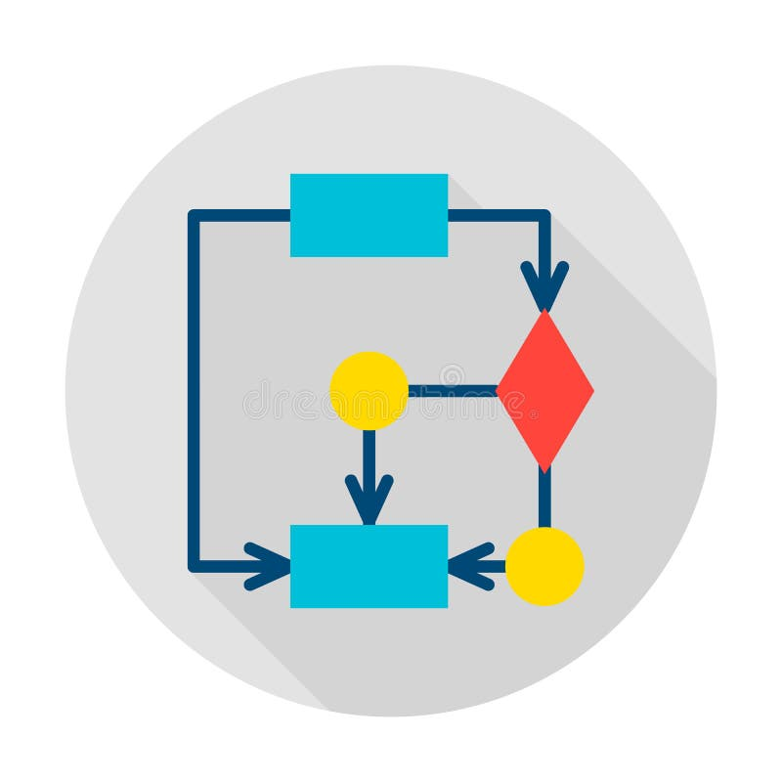 | A set of sequenced instructions or rules for solving a problem or completing a task in a logical order.
bug  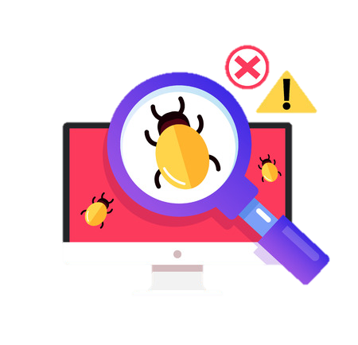 | A problem in a computer program that stops it working the way it  was designed.
condition  | A block of code that will only run if a certain event is true or false.
debug 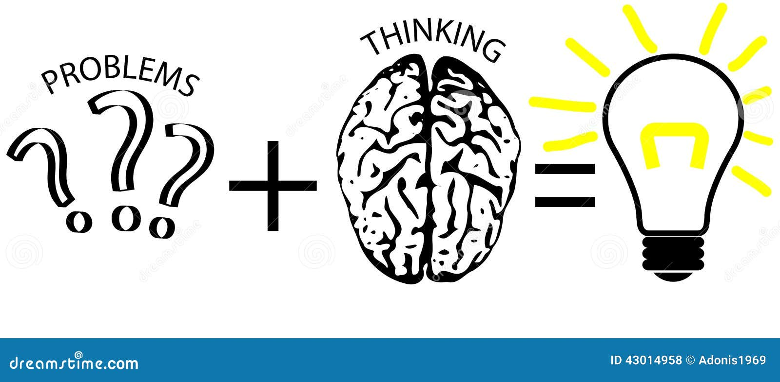 | To find, remove or correct errors in a computer program.
input  | Information going into the computer. Can include moving or clicking the mouse, using the keyboard, swiping and tilting the device.
program 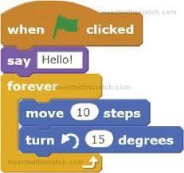 | A set of instructions written in code that performs a given task.
selection  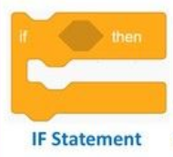 | A decision made by a computer depending on the information it receives.
statement  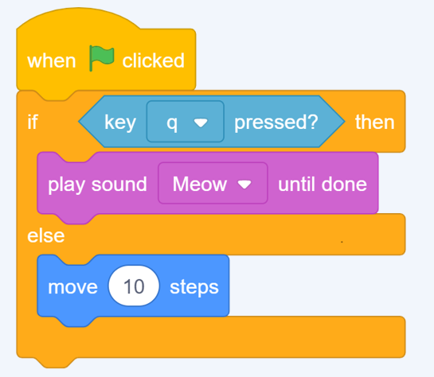 | The smallest element of a programming language which expresses an action to be carried out.

Overview
Learners will develop their knowledge of ‘selection’ by revisiting how ‘conditions’ can be used in programming, and then learning how the ‘if… then… else...’ structure can be used to select different outcomes depending on whether a condition is ‘true’ or ‘false’. They learn how to write programs that ask questions and use selection to control the outcomes based on the answers given. They use this knowledge to design a quiz in response to a given task and implement it as a program. To conclude the unit, learners evaluate their program by identifying how it meets the requirements of the task.

National Curriculum:
Computing
- Design, write, and debug programs that accomplish specific goals, including controlling or simulating physical systems; solve problems by decomposing them into smaller parts
- Use sequence, selection, and repetition in programs; work with variables and various forms of input and output
- Use logical reasoning to explain how some simple algorithms work and to detect and correct errors in algorithms and programs
Internet safety
- Use technology safely, respectfully, and responsibly; recognise acceptable/unacceptable behaviour; identify a range of ways to report concerns about content and contact.

Blooms Taxonomy – Specific Verbs to Use in Lesson Aims
Knowledge: Describe, find, identify, list, locate, name, recognise, retrieve Comprehension: Classify, compare, explain, infer, interpret, paraphrase, summarise Application: Carry out, implement, use Analysis: Deconstruct, Organise, outline, structure Synthesis: Construct, design, devise, invent, make, plan, produce, Evaluation: Appraise, assess, choose,
Teaching Sequence
Programming B - Selection in Quizzes
- To explain how selection is used in computer programs.
- To relate that a conditional statement connects a condition to an outcome.
- To explain how selection directs the flow of a program.
- To design a program that uses selection.
- To create a program that uses selection.
- To evaluate my program.

Online Safety
- To explain the benefits and limitations of using different types of search technologies.
- To evaluate digital content and explain how to make choices about what is trustworthy.
- To identify ways the internet can draw us to information for different agendas.
- To assess and justify when it is acceptable to use the work of others.
- To give examples of content that is permitted to be reused and know how this content can be found online.

