What should I already know?
Investigate and analyse the existing products that they have researched in small groups to understand their purpose. Discus the given design brief.
As a class, create their design criteria.
Design their own product using labelled drawings.
List all the resources that they require for the product.
Based on their individual designs, choose from a variety of materials and perform practical skills e.g measuring, cutting joining and finishing the product independently with some accuracy.
Testing their products.
Evaluate their ideas and products against the design criteria using a given sheet with leading questions.

Technical Knowledge and skills:

- To measure with more accuracy and join materials, cut them with more independence to achieve precision

- To ensure the product is strong and fit for purpose

- To begin to reinforce and strengthen a 3D frame

Key Vocabulary
adapting | make (something) suitable for a new use or purpose; modify
compression | Pressure (weight) being applied.
reinforce | strengthen or support (an object or substance), especially with additional material.
stability | the strength to stand or endure
tension | Stretching something tightly

DT Skills:
Investigate and analyse the existing products that they have researched in pairs to understand their purpose and audience. Discus the given design brief.
Create their design criteria in small groups/ pairs.
Design their own product using labelled drawings and PurpleMash.
List all the resources that they require for the product.
Based on their individual designs, choose from a variety of materials and perform practical skills e.g measuring, cutting joining and finishing the product independently with accuracy most of the time.
Testing their products.
Evaluate in detail their ideas and products against the design criteria using a given sheet with leading questions incorporating peer feedback.

Designer
Isambard Kingdom Brunel
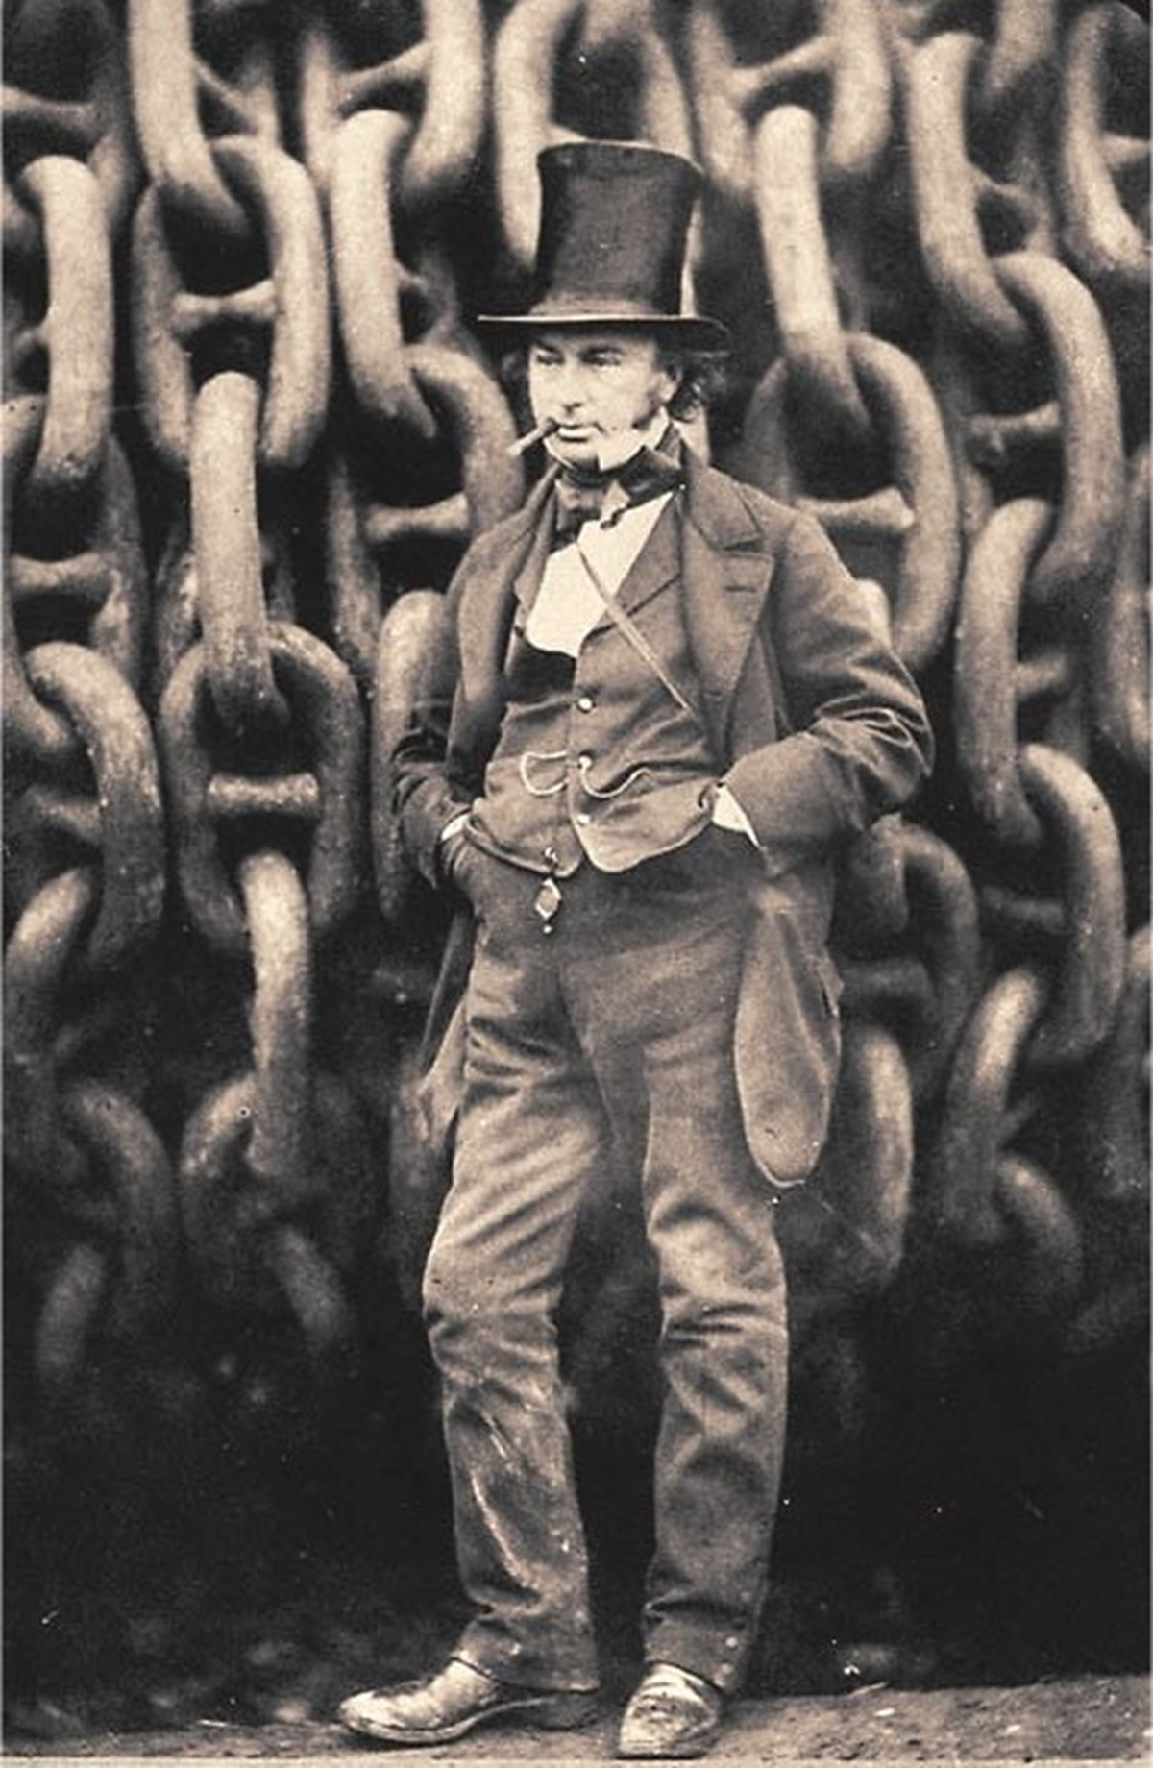

Key Knowledge
Beam Bridges
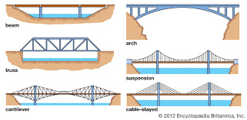
Using junior hacksaws
