Key Vocabulary and Definitions:
County  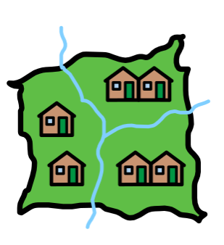 | A division of land within a country
Grid reference  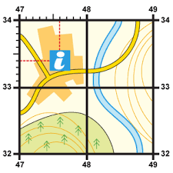 | A location described using numbers to indicate longitude and latitude
Human geography   | Features of land that have been made by humans (houses, roads, canals etc.)
Key  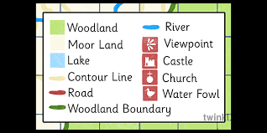 | A selection of symbols to help you read a map
Locomotive  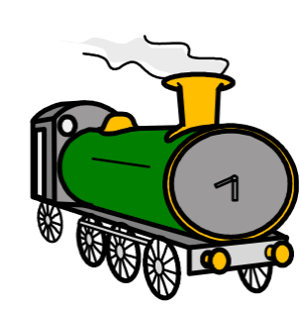 | A powered train engine (steam, diesel or electric)
Ordnance survey map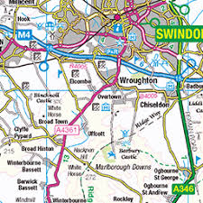 | A detail map of areas of the UK produced by an organization
Physical geography  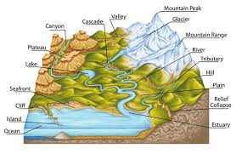 | Features of land that are natural (mountains, rivers, beaches etc.)
Symbol  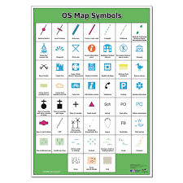 | A small drawing/logo that resembles a feature on a map

What should I already know?
- Name, locate and identify characteristics of the four countries and capital cities of the UK
- Use basic geographical vocabulary to refer to key human and physical features

Geographic Skills:
- Locate and name the main counties and cities in England.
- Compare land use maps of UK from past with the present
- Use the eight points of a compass, four-figure grid references, symbols and key
- Linking with History, compare land use maps of UK from past with the present, focussing on land use.

Blooms Taxonomy – Specific Verbs to Use in Lesson Aims
Knowledge: Describe, find, identify, list, locate, name, recognise, retrieve Comprehension: Classify, compare, explain, infer, interpret, paraphrase, summarise Application: Carry out, implement, use Analysis: Deconstruct, Organise, outline, structure Synthesis: Construct, design, devise, invent, make, plan, produce, Evaluation: Appraise, assess, choose,

Teaching Sequence

- To locate and name the main counties and cities in England.
- To compare maps from current day Swindon to maps from the 1800s.
- To use eight points of a compass and grid references.
- To use Ordnance Survey maps to plan an alternative route to the Works.
- To debate why Swindon’s inhabitants may have been against the railway. (TRIP)

Key Knowledge
