Key Vocabulary and Definitions:

|  |  |
| --- | --- |
| Baptism | Sprinkling water on to a person’s forehead or immersing them in water, symbolising purification or regeneration and admission to the Christian Church. |
| Co-existing  Coexisting in an “us vs. them” world ... | Existing at the same time or in the same place. |
| Consubstantial  Jesus is Consubstantial with the Father ... | They exist separately and together as one. |
| Creed  Apostles' Creed - FREE PRINTABLE ... | A statement of belief usually recited by believers during services in a church. |
| hymns | A religious song or poem of praise to God |
| Monotheism  Monotheism – Quran Subjects | Belief in one God only. |
| Sign of the Cross  The Sign of the Cross. I distinctly ... | Used by ministers to confer the blessing of the Trinity or by individuals to bless themselves. |
| Trinity  Trinity - Wikipedia | The complete relationship between God (the Father), Jesus (his son) and the Holy Spirit. |

What should I already know?

* Can be linked to the Baptism of Christ by John the Baptist in which all 3 members of the Trinity are present: God the Father speaks; the Holy Spirit descends as a dove onto Jesus in the water. (Cited in the Yr. 4 Optional enquiry on the 4 Gospels).

RE Knowledge:

|  |
| --- |
| * The Trinity is the complete relationship between God (the Father), Jesus (his son) and the Holy Spirit * The three are “consubstantial”, which means that they exist separately and together as one. * This is called a “mystery” as well as a belief because it is not easily understood by humans that 3 “persons” can be 1 person. Christians believe that although there are three persons within the Trinity, there is only one God who is all 3 persons. * The greatest aspect of this enquiry is to ensure the children understand that Christians believe this is not 3 Gods co-existing together to appear in different ways, but only one God. |

|  |
| --- |
|  |

Blooms Taxonomy – Specific Verbs to Use in Lesson Aims

Knowledge: Describe, find, identify, list, locate, name, recognise, retrieve Comprehension: Classify, compare, explain, infer, interpret, paraphrase, summarise Application: Carry out, implement, use Analysis: Deconstruct, Organise, outline, structure Synthesis: Construct, design, devise, invent, make, plan, produce, Evaluation: Appraise, assess, choose,

Teaching Sequence

1. To explain the meaning of consubstantial.
2. To investigate what does the Bible say about the Trinity?
3. To investigate what does the Church say about the Trinity?
4. To research what other sources say about the Trinity.
5. To consider how the Trinity helps a Christian understand God.
6. To describe different parts of my own character.

Key Knowledge

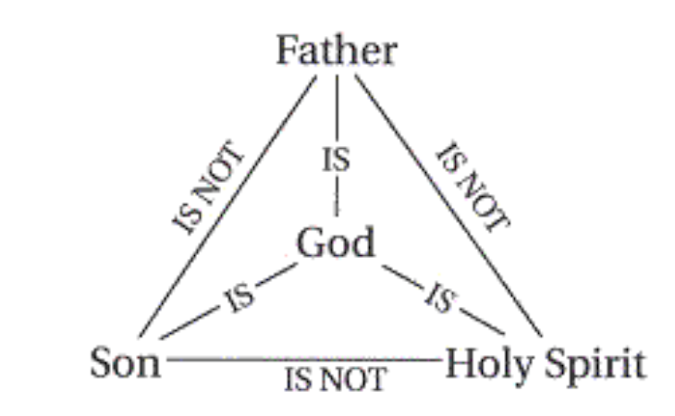

This enquiry investigates the Christian belief in the Trinity. This is the complete relationship between God (the Father), Jesus (his son) and the Holy Spirit. The three are “consubstantial”, which means that they exist separately and together as one.

The concept of the Trinity is difficult to explain but is demonstrated throughout the Bible references given as resources. Throughout the history of the Bible, reference if made to the 3 persons of the Trinity and Jesus himself uses the phrase “Father, Son and Holy Spirit” in Matthew 28: 18-20.

Children may also have seen the “Sign of the Cross” which is used by ministers to confer the blessing of the Trinity, and it is also used personally by some denominations such as Roman Catholics, to bless themselves. (Some footballers and other sportspeople do this before an event so the children may be aware of it.)

The greatest aspect of this enquiry is to ensure the children understand that Christians believe this is not 3 Gods co-existing together to appear in different ways, but one God and only one God. This belief in one God is called monotheism. So, Christians believe that although there are three persons within the Trinity, there is only one God who is all 3 persons.