What should I already know?
- Notice that animals, including humans, have
offspring which grow into adults.
(Y2 - Animals, including humans)

Key Vocabulary and Definitions:

Adolescence | 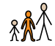 | The period of transition between child and  adult.
Adulthood | 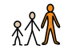 | Fully grown and mature.
Embryo | 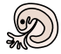 | Unborn offspring.
Fertilisation |  | The fusion of a male and female cell.
Fetus | 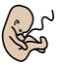 | Unborn offspring of a mammal.
Gestation | 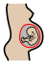 | Time of development between fertilization  and birth.
Hormones | 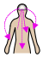 | A substance in the body that stimulates  specific cells or tissues into action.
Life expectancy | 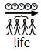 | The average period that a person may  expect to live.
Prenatal |  | Before birth.
Puberty |  | The period of time when adolescents  become capable of reproduction.

Scientific Knowledge:

- Describe the changes as humans develop to old age.

Teaching Sequence

- To describe the stages of human development and explain how babies grow and develop.
- To know the stages in the gestation period of humans and compare them to other animals.
- To compare changes during puberty.
- To understand how the body changes during adulthood and old age.
- To measure and record data to show how humans develop as they grow older. (TAPS)

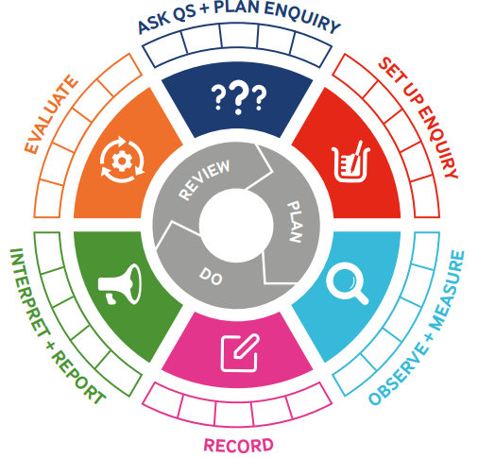
Blooms Taxonomy – Specific Verbs to Use in Lesson Aims
Knowledge: Describe, find, identify, list, locate, name, recognise, retrieve Comprehension: Classify, compare, explain, infer, interpret, paraphrase, summarise Application: Carry out, implement, use Analysis: Deconstruct, Organise, outline, structure Synthesis: Construct, design, devise, invent, make, plan, produce, Evaluation: Appraise, assess, choose,

Working Scientifically

Term 4 | Let’s Talk (Explorify) | Scientific Knowledge | Scientific skill
Lesson 1 | https://explorify.uk/en/activities/have-you-ever/noticed-how-babies-change-as-they-become-toddlers/classroom  Have you ever..? | - Describe the changes as humans develop to old age. | Observe and measure
Lesson 2 |  | - Describe the changes as humans develop to old age. | Observe and measure
Lesson 3 | https://explorify.uk/en/activities/what-if/we-didnt-use-transport-to-get-to-school  what if…? | - Describe the changes as humans develop to old age. | Observe and measure
Lesson 4 | https://explorify.uk/en/activities/what-if/the-average-lifespan-of-a-human-was-200  What if…? | - Describe the changes as humans develop to old age. | Observe and measure
Lesson 5 | https://explorify.uk/en/activities/listen-what-can-you-hear/when-we-were-young  What can you hear? | - Describe the changes as humans develop to old age. | Observe and measure

