What should I already know?

|  |
| --- |
| * Notice that animals, including humans, have   offspring which grow into adults.  (Y2 - Animals, including humans) |

Key Vocabulary and Definitions:

|  |  |  |
| --- | --- | --- |
| Adolescence |  | The period of transition between child and  adult. |
| Adulthood |  | Fully grown and mature. |
| Embryo |  | Unborn offspring. |
| Fertilisation |  | The fusion of a male and female cell. |
| Fetus |  | Unborn offspring of a mammal. |
| Gestation |  | Time of development between fertilization  and birth. |
| Hormones |  | A substance in the body that stimulates  specific cells or tissues into action. |
| Life expectancy |  | The average period that a person may  expect to live. |
| Prenatal |  | Before birth. |
| Puberty |  | The period of time when adolescents  become capable of reproduction. |

Scientific Knowledge:

* Describe the changes as humans develop to old age.

Teaching Sequence

1. To describe the stages of human development and explain how babies grow and develop.
2. To know the stages in the gestation period of humans and compare them to other animals.
3. To compare changes during puberty.
4. To understand how the body changes during adulthood and old age.
5. To measure and record data to show how humans develop as they grow older. (TAPS)

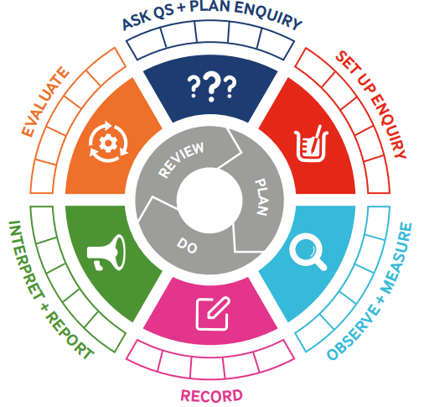



Blooms Taxonomy – Specific Verbs to Use in Lesson Aims

Knowledge: Describe, find, identify, list, locate, name, recognise, retrieve Comprehension: Classify, compare, explain, infer, interpret, paraphrase, summarise Application: Carry out, implement, use Analysis: Deconstruct, Organise, outline, structure Synthesis: Construct, design, devise, invent, make, plan, produce, Evaluation: Appraise, assess, choose,

Working Scientifically

|  |  |  |  |
| --- | --- | --- | --- |
| Term 4 | Let’s Talk (Explorify) | Scientific Knowledge | Scientific skill |
| Lesson 1 | <https://explorify.uk/en/activities/have-you-ever/noticed-how-babies-change-as-they-become-toddlers/classroom>  Have you ever..? | * Describe the changes as humans develop to old age. | Observe and measure |
| Lesson 2 |  | * Describe the changes as humans develop to old age. | Observe and measure |
| Lesson 3 | <https://explorify.uk/en/activities/what-if/we-didnt-use-transport-to-get-to-school>  what if…? | * Describe the changes as humans develop to old age. | Observe and measure |
| Lesson 4 | <https://explorify.uk/en/activities/what-if/the-average-lifespan-of-a-human-was-200>  What if…? | * Describe the changes as humans develop to old age. | Observe and measure |
| Lesson 5 | <https://explorify.uk/en/activities/listen-what-can-you-hear/when-we-were-young>  What can you hear? | * Describe the changes as humans develop to old age. | Observe and measure |