Key Vocabulary and Definitions:

|  |  |
| --- | --- |
| Web page | is a hypertext document on the World Wide Web. Web pages are delivered by a web server to the user and displayed in a web browser. |
| Website | a set of related web pages located under a single domain name, typically produced by a single person or organization. |
| Logo | a symbol or other small design adopted by an organization to identify its products |
| Layout | the way in which text or pictures are set out on a page. |
| Media | means of communication, as radio and television, newspapers, magazines, and the internet, that reach or influence people widely |
| Purpose | the reason for which something is done or created or for which something exists. |
| Hyperlink | a link from a [hypertext](https://www.google.com/search?safe=active&rlz=1C1GCEV_enGB949GB950&q=hypertext&si=ACFMAn8hzZSJQsgXIYlkGc-z1vmpEI947jiktNwS5N_goUIllq8Kq6BL-Hi3pPUWAhH-3q4zLNfIIQ47YJWYnKajJM74ihusTQ%3D%3D&expnd=1) document to another location, activated by clicking on a highlighted word or image. |

Progression

This unit progresses students’ knowledge and understanding of the following: digital writing, digital painting, desktop publishing, digital photography, photo editing, and vector drawing.

Curriculum links

* Use search technologies effectively, appreciate how results are selected and ranked, and be discerning in evaluating digital content
* Select, use, and combine a variety of software (including internet services) on a range of digital devices to design and create a range of programs, systems, and content that accomplish given goals, including collecting, analysing, evaluating, and presenting data and information.
* use technology safely, respectfully, and responsibly; recognise acceptable/unacceptable behaviour.

Teaching Sequence

**Online Safety: Health, well-being and lifestyle**.

* + - 1. To identify and critically evaluate online content relating to gender, race, religion and other groups
      2. To describe issues online that could make anyone feel sad, worried, uncomfortable or frightened
      3. To explain the importance of asking until I get help
      4. To describe effective ways people can manage passwords
      5. To explain what to do if a password is shared, lost or stolen

**Creating Media – Web page creation**

1. To explore a website and discuss the different types of media used on websites.
2. To recognise the common features of a web page and suggest media to include on my page.
3. To say why we should use copyright-free images and find copyright-free images.
4. To add content to my own web page and preview what my web page looks like.
5. To use hyperlinks to link multiple pages together, and to link to other people’s work.

Blooms Taxonomy – Specific Verbs to Use in Lesson Aims

Knowledge: Describe, find, identify, list, locate, name, recognise, retrieve Comprehension: Classify, compare, explain, infer, interpret, paraphrase, summarise Application: Carry out, implement, use Analysis: Deconstruct, Organise, outline, structure Synthesis: Construct, design, devise, invent, make, plan, produce, Evaluation: Appraise, assess, choose,

Final Outcome

At the end of the term, the children will create their own web page in Google Sites. Learners who have created and hyperlinked their initial set of subpages continue to add further pages as detailed on their design with support from the handout.

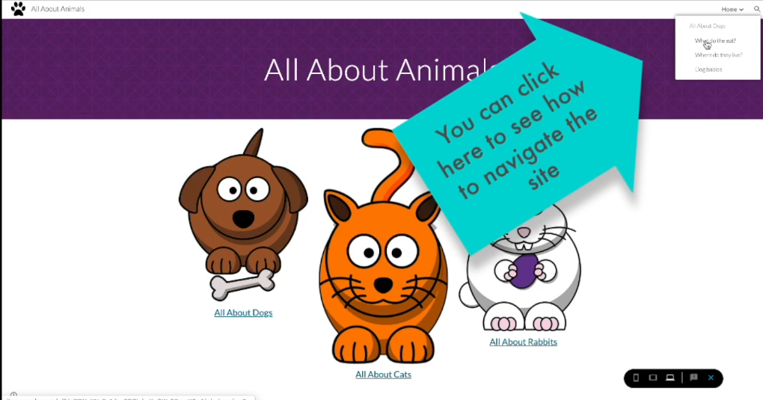

|  |  |
| --- | --- |
| Aims | Advice |
| To identify and critically evaluate online content relating to gender, race, religion and other groups |  |
| To describe issues online that could make anyone feel sad, worried, uncomfortable or frightened |  |
| To explain the importance of asking until I get help |  |
| To describe effective ways people can manage passwords |  |
| To explain what to do if a password is shared, lost or stolen |  |