Year 3 Spring 2 Newsletter

Dear Parents and Carers,
We hope you have had a lovely half term break and you are ready for another exciting term in Year 3!

English | This term, we are going to be using “Fly, Eagle, Fly!” by Christopher Gregorowski as our focused text. The story is a traditional African folktale and follows a farmer, searching for his lost calf, who finds a baby eagle that has blown out its nest. It encourages children to act as an eagle and “lift off and soar”. The fiction outcome will be to create an innovated narrative using inverted commas to punctuate speech, using exclamation marks and to organise our ideas into paragraphs. Later in the term, we will write a persuasive speech based on the book. Children will use conjunctions for cause, subordinating conjunctions and exploring how we can write for a range of purposes.
Reading comprehension | In Reading, we will be looking closely at our new reading text, “The Sheep Pig”. This story follows Babe, an orphaned piglet, as he tries to learn how to be a sheep-dog from his new friend, Fly. The children will make inferences from the text and begin to explain and justify inferences with evidence from the text. Over the term, we will continue to recap skills such as understanding the meaning of words in context and finding and retrieving words in a text.
Maths | In Maths, we will be exploring multiplication and division. Please encourage your child to practice their times tables at home as this will really help them this term! In our measurement lessons we will look at money. We will learn to use combinations of coins to make amounts beyond £1 and look at adding and subtracting amounts. The children will also be developing their problem-solving skills over the course of the term.
Science | In Science, we will be learning about ‘Plants’. We will explore the part that flowers play in the life cycle of flowering plants. We will investigate the process of fruit development from pollinated flowers and look at the functions of fruit in the life cycle of plants.
PE | In PE we will be learning about gymnastics. We will be exploring the different types of movements which make up a gymnastics routine, as well as developing our core strength and flexibility. We will be working in groups to create routines as part of our PE assessments.
History | In History will be exploring The Romans. The children will place the Roman era on a timeline and find out how and why the Romans invaded Britain. We will be able to find out who was in Britain when the Romans invaded and learn about their way of life. Finally, they will explore who Boudicca was from different points of view. Excitingly, we will be going on a fantastic trip to immerse ourselves completely in Roman Britain!
RE | The question we will be investigating in RE is “What is good about Good Friday”.  Children will understand the significance of the bread and wine to Christians and will later on sequence the events to ‘Good Friday’. We will look at how to show love and gratitude to people who are special to us.
Art | In Term 4, Year 3 will be looking at the artwork of Laura Child, the creator of “Charlie and Lola”, and creating their own cut-paper animation using her influence. They will have to think about the background, foreground and characters that they want to include in their animation.
Computing & Online Safety | In online safety the children will understand why spending too much time using technology can have a negative impact on anyone. We will also explore why some online activities have age restrictions. In ‘Branching Databases’ children will learn how to collect data and present it in a well-structured model that can be used by others.

Additional information
PE
We have PE on Monday afternoons; please ensure that your child brings in their PE kit on Monday mornings (otherwise they can be brought in on Friday to leave over the weekend).
Their kit should consist of a white t-shirt, dark blue or black shorts/jogging bottoms and trainers/daps.
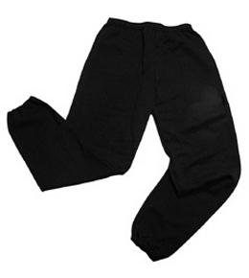
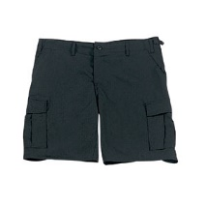


No jewellery is to be worn; hair needs to be tied back and head scarves must be short and tight fitting. These are all to ensure the safety of your child.

READING
Please ensure that your child is reading regularly at home (at least 4 times a week) and please take the opportunity to support your child whilst they read. It is also important that you listen to your child read books as much as possible as this will help both their reading and writing abilities. Reading comprehension is a big focus so they will need your support to help practice the skills we will teach. You can help at home by asking your child questions about their book after they have read such as ‘How do you know he is angry?’ or ‘Why is she happy?’

READING RECORDS
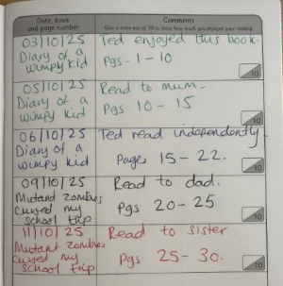
Here is an example of a completed Reading Record entry. Children can read any book of their choice. Reading Records must be brought into school every week to be checked by their teacher. Every 20 reads, the children get a reading prize!

HOMEWORK
Your child will bring home a list of spellings which they will be expected to learn each week. There will also be maths homework. Your child will bring their homework folder home on a Friday with an expectation that they are back in school by Wednesday morning.

SNACKS AND LUNCHBOXES
We encourage all the children to lead fit and healthy lifestyles. Break time snacks should be healthy and include fruit or vegetables – crisps, cakes or chocolate bars will not be allowed at break time. Lunchboxes need to have a variety of food groups within them. A main part of the meal needs to be included (e.g. sandwiches, wraps, rice) alongside some of the following suggestions:
- Yoghurt
- Fruit
- Vegetable sticks
- Jelly
- Crisps / Biscuit
There is lots of advice and suggestions at:
https://www.nhs.uk/healthier-families/recipes/healthier-lunchboxes/

Many thanks,
Miss Smith, Mrs Qazi and Miss Shiloh
Year 3

