Year 3 Spring 2 Newsletter

Dear Parents and Carers,

We hope you have had a lovely half term break and you are ready for another exciting term in Year 3!

|  |  |
| --- | --- |
| English | This term, we are going to be using “Lights on Cotton Rock” by David Litchfield as our focused text. The story follows a main character called Heather who meets a friendly alien. They continue to be friends throughout her life. The fiction outcome will be to create an innovated narrative using subordinating conjunctions, past tense and inverted commas to show dialogue. Later in the term, we will write an eye-witness report based around the book. Children will use fronted adverbials, coordinating conjunctions, apostrophes for contraction and revisiting inverted commas to show dialogue. |
| Reading comprehension | In Reading, we will be looking closely at our English text, “Lights on Cotton Rock”. The children will make inferences from the text and begin to explain and justify inferences with evidence from the text. Over the term, we will continue to recap skills such as understanding the meaning of words in context and finding and retrieving words in a text. |
| Maths | In Maths, we will use the formal written method to multiply and divide up to 2-digit numbers by 1 digit. We will also look at multiplying and dividing by 10 and using multiplication and division to solve problems. In our measurement lessons we will look at money. We will learn to use combinations of coins to make amounts beyond £1 and look at adding and subtracting amounts. |
| Science | In Science, we will be learning about ‘Plants’. We will explore the part that flowers play in the life cycle of flowering plants. We will investigate the process of fruit development from pollinated flowers and look at the functions of fruit in the life cycle of plants. |
| PE | In PE we will be learning to play Rounders. The children will learn to play co-operatively in a team. They will practice how to throw and catch a ball and be able to successfully strike an object. |
| History | In History will be exploring “Romans”. The children will place the Roman era on a timeline and find out how and why the Romans invaded Britain. The children will be able to find out who was in Britain when the Romans invaded and learn about their way of life. Finally, they will explore who Boudicca was from different points of view. |
| RE | The question we will be investigating in RE is “What is good about Good Friday”.  Children will understand the significance of the bread and wine to Christians and will later on sequence the events to ‘Good Friday’. We will look at how to show love and gratitude to people who are special to me. |
| Art | In Term 4, Year 3 will be looking at the artwork of Laura Child and creating their own cut-paper animation using her influence. They will have to think about the background, foreground and characters that they want to include in their animation. |
| Computing & Online Safety | In online safety the children will understand why spending too much time using technology can have a negative impact on anyone. We will also explore why some online activities have age restrictions. In ‘Branching Databases’ children will learn how to collect data and present it in a well structured model that can be used by others. |

Additional information

PE

Please note that your child will need to have the correct PE kit in school **every day.**

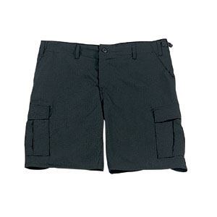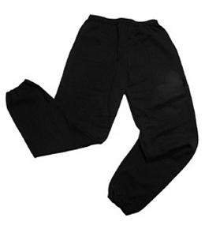Their kit should consist of a white t-shirt, dark blue or black shorts/jogging bottoms and trainers/daps.



**No jewellery is to be worn; hair needs to be tied back and head scarves must be short and tight fitting.** These are all to ensure the safety of your child.

**READING**

Every child has their own individual Reading Record and needs to be reading at home 4 times a week. Adults should be reading with their child and making a record in the Reading Record showing the title of the book, the page number and make a few comments about the reading. Reading Records need to be brought into school on a Wednesday (with Homework Folders) so the reads can be counted. For every 20 reads, children will receive a fun reading prize from the office!

**HOMEWORK**

Each week your children will bring home a maths and spelling homework sheet with different sections to recap learning which has already taken place. All homework is given out on a Friday and needs to be returned by the following Wednesday.

If you have any questions, please do not hesitate to come in and see us at the end of the school day.

**SNACKS AND LUNCHBOXES**

We encourage all the children to lead fit and healthy lifestyles. Break time snacks should be healthy and include fruit or vegetables – crisps, cakes or chocolate bars will not be allowed at break time. Lunchboxes need to have a **variety** of food groups within them. A main part of the meal needs to be included (e.g. sandwiches, wraps, rice) alongside some of the following suggestions:

* Yoghurt
* Fruit
* Vegetable sticks
* Jelly
* Crisps / Biscuit

There is lots of advice and suggestions at:

https://www.nhs.uk/healthier-families/recipes/healthier-lunchboxes/

Many thanks,

Mrs Kearns, Mrs Parker, Miss Brazewell and Mr Cowley

Year 3