Year 3 Summer 2 Newsletter

Dear Parents and Carers,

We hope you have had a lovely half term break and you are ready for our final, exciting term in Year 3! As the weather warms up, please ensure your child is coming into school with a water bottle and a hat. Sun cream should be applied at home although some may wish to have a small bottle with them during the school day. The school does not provide sun cream.

|  |  |
| --- | --- |
| English | This term, we will be reading “The Iron Man” by Ted Hughes. This is a story of bravery, friendship and expecting the unexpected! We will use it to guide our English lessons to create a narrative scene in the first half of the term, followed by a non-chronological report in the second half of the term. We will be exploring and using these skills: present perfect tense, correctly punctuating direct speech, pronouns and alterative nouns, describing characters in narratives, noun phrases expanded with adverbs, commas in a list and adverbs, prepositions and conjunctions for place. |
| Reading comprehension | In Reading, we will be looking closely at our English text, “The Iron Man”. The children will make inferences from the text and begin to explain and justify inferences with evidence from the text. Over the term, we will continue to recap skills such as understanding the meaning of words in context and finding and retrieving words in a text. We will also be expanding our inference skills by looking for clues within the context of the text. |
| Maths | We will learn to measure length, mass and capacity. From measuring lengths to comparing capacity of different containers, we will have plenty of opportunities to practically apply the newly learnt skills. We will also find the perimeter of simple 2D shapes by measuring the length of each side with a ruler and then adding the lengths together. The children will also learn about statistics and data handling towards the end of the term. |
| Science | In Science, we will be learning about ‘Plants’. We will explore the part that flowers play in the life cycle of flowering plants. We will investigate the process of fruit development from pollinated flowers and look at the functions of fruit in the life cycle of plants. |
| PE | PE in Term6 will be all about cricket. We are very lucky as we have external providers from Chance to Shine. This will allow the children to develop a comprehensive understanding of how to play cricket and to have a year-group tournament at the end. We will also be swimming each week. This is compulsory for every child. |
| History | In History will be exploring Ancient Egypt. The children will be able to identify why Ancient Egypt is so important and the impact it has had on the modern world. We will also be exploring the cultural significance of hieroglyphics and the pyramids. The children will learn about the beliefs and mythologies of the ancient Egyptians, as well as looking into their daily lives. |
| RE | This term we are continuing our learning into Hinduism. We will be focusing on pilgrimages to the River Ganges to explain why water is important to Hindus. We will also be looking at what special feelings a Hindu feels when they visit the River Ganga. |
| DT | In DT this term we will be continuing with structures and focusing on kites. We will be looking at existing kites on the market, discussing our design brief and creating a design criteria. Next, we will start making our own kites based on their designs which will include measuring, cutting, joining and finishing the product independently. Finally, we will test our products and evaluate them against the design criteria. |
| Computing & Online Safety | In Computing this term, we will be building on our coding work from earlier on in this year. So far, we've explored using the programme Scratch to code our own mini animals and set them on their own adventures. By developing our coding skills, we will be able to design and create our very own maze-based challenges. |

Additional information

PE

Please note that your child will need to have the correct PE kit in school **every day.**

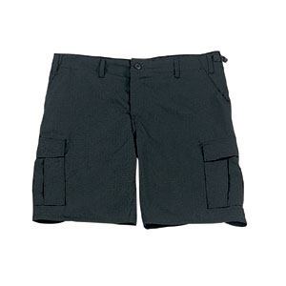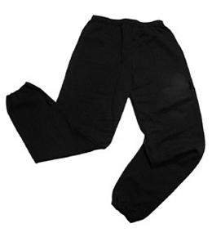Their kit should consist of a white t-shirt, dark blue or black shorts/jogging bottoms and trainers/daps.

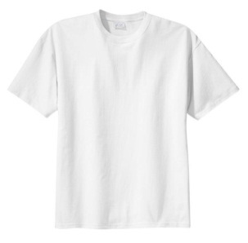

**No jewellery is to be worn; hair needs to be tied back and head scarves must be short and tight fitting.** These are all to ensure the safety of your child.

**READING**

Every child has their own individual Reading Record and needs to be reading at home 4 times a week. Adults should be reading with their child and making a record in the Reading Record showing the title of the book, the page number and make a few comments about the reading. Reading Records need to be brought into school on a Wednesday (with Homework Folders) so the reads can be counted. For every 20 reads, children will receive a fun reading prize from the office!

**HOMEWORK**

Each week your children will bring home a maths and spelling homework sheet with different sections to recap learning which has already taken place. All homework is given out on a Friday and needs to be returned by the following Wednesday.

If you have any questions, please do not hesitate to come in and see us at the end of the school day.

**SNACKS AND LUNCHBOXES**

We encourage all the children to lead fit and healthy lifestyles. Break time snacks should be healthy and include fruit or vegetables – crisps, cakes or chocolate bars will not be allowed at break time. Lunchboxes need to have a **variety** of food groups within them. A main part of the meal needs to be included (e.g. sandwiches, wraps, rice) alongside some of the following suggestions:

* Yoghurt
* Fruit
* Vegetable sticks
* Jelly
* Crisps / Biscuit

There is lots of advice and suggestions at:

https://www.nhs.uk/healthier-families/recipes/healthier-lunchboxes/

Many thanks,

Miss Brazewell, Mrs Kearns, Mrs Barder and Mr Cowley

Year 3