Year 4 Spring Term 1

Dear Parents and Carers,

We hope that you’ve had an enjoyable holiday and that your children are ready for Term 3.

|  |  |
| --- | --- |
| The Wolves in the Walls - WikipediaEnglish Writing | In English, this term, we will be studying the book ‘The Wolves in the Walls’ by Neil Gaiman and using the text to support our year 4 writing skills. We will cover the national curriculum grammar, punctuation and spelling targets in our fiction phase such as using fronted adverbials for place and manner using a comma correctly and to punctuate direct speech correct.  In addition, in our non-fiction unit we will be covering the grammar skills of using a wide variety of subordinating conjunctions, to use present tense correctly and consistently throughout a piece of writing and to use paragraphs and subheading in non-fiction writing. |
| Reading comprehension | As well as reading every day, it is also extremely important to practise asking and answering questions about the text. Reading comprehension forms a prominent part of the curriculum, and we will practise the skills of answering retrieval and inference questions.  In the guided reading sessions, we will be revealing our new story and we will propose different activities to aid understanding of the theme/ context of the chosen book. |
| Maths | In maths, we will learn the multiples of 11 & 12 and the division facts related to those times tables.  We will practise the formal written method for addition and subtraction. |
| Science | In science, this term covers the topic: ‘States of Matter’. We will look at the properties of solids, liquids and gases. We will complete a scientific experiment to investigate different states of matter: condensation and evaporation. |
| PE | We will be doing Invasion Games such as invasion games. |
| History | This term, our topic will be History and we will be studying the ‘Vikings’. This includes looking at how the legal system worked in Anglo-Saxon Britain and how the last Anglo-Saxon kings shaped Britain after the Viking invasion. |
| Music | In music, we will be following the Charanga scheme of work and learning a new song, ‘Lean on me’. |
| RE | In RE, we will be studying Islam and exploring the question “What is the best way for a Muslim to lead a good life?” |
| ICT | In computing lesson, we will be looking at ‘Programming ’ and online safety including online reputation. |

Additional information

PE

This year our PE session is on a Wednesday. Please note that your child will need to have the correct PE kit in school every day.

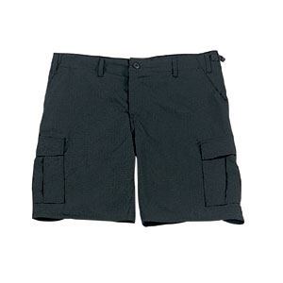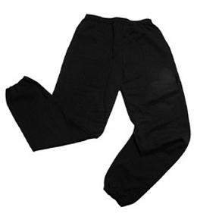Their kit should consist of a white t-shirt, dark blue or black shorts/jogging bottoms, jumper and trainers/daps.



**No jewellery is to be worn; hair needs to be tied back and head scarves must be short and tight fitting.** These are all to ensure the safety of your child.

READING

Every child will have their own individual book. It is also important that you listen to your child read books as much as possible, as this will help both their reading and writing abilities. Reading comprehension is a big focus so they will need your support to help practise the skills we will teach. You can help at home by asking your child questions about their book after they have read such as ‘How do you know he is angry?’ or ‘Why is she happy?’

HOMEWORK

Your child will receive homework each week. This homework will be handed out on **Friday** and should be completed by the following **Wednesday**. The homework contains a spelling activity, a piece of Maths Homework, which will enable your child to practise what they have been learning in class that week, the previous week, as well as work from previous terms as well.

In preparation for Multiplication Times Tables Check , the children can practise their times tables on <https://urbrainy.com/mtc> .

If you have any questions, please do not hesitate to contact the school office.

Many Thanks

Miss Shiloh, Mr Cowley and Miss Gheorghe

The Year 4 Team