Year 4 Spring Term 4

Dear Parents and Carers,
We hope that you’ve had an enjoyable holiday and that your children are ready for Term 4.

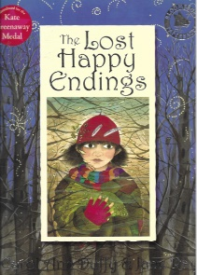  English | In English, this term, we will be studying the book ‘The lost happy endings” by Carol Ann Duffy and using the text to support our year 4 writing skills.  We will cover the national curriculum grammar, punctuation and spelling targets such as developing characters and settings in narratives, maintain cohesion across a piece of writing, including through the use of a variety of nouns and pronouns, accurately manage tense changes where needed e.g. a story written in the past tense with present tense for speech.
Reading comprehension  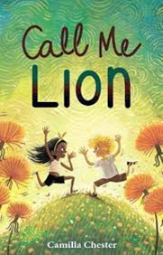 | As well as reading every day, it is also extremely important to practise asking and answering questions about the text. Reading comprehension forms a prominent part of the curriculum, and we will practise the skills of answering retrieval and inference questions.  In the guided reading sessions, we will be revealing our new story and we will propose different activities to aid understanding of the theme/ context of the chosen book.
Maths | In maths, we will use the formal written method to multiply and divide up to 3-digit numbers by 1 digit. We will also look at multiplying and dividing by 10 & 100. In our geometry lessons, we will look identifying and comparing angles.
Science | Science this term covers the topic: ‘Sound’. We will discover how sound is made and complete will complete scientific experiments to investigate patterns between the volume of a sound and the strength of the vibrations.
PE | We will be focusing on tag rugby.
Geography | This term, our topic will be Geography and we will be studying ‘The World We Live in’. This includes locating countries using world maps and atlases and identifying human and physical features of the land. We will compare two cities London and Paris.
D&T | In D&T, we will be using textiles to create bookmarks. We will learn different types of stitches .
RE | In RE, we will be studying forgiveness from a Christian perspective.
Computing | In computing lessons, we will be looking at ‘Media Audio Production ’ including using the GarageBand App. In online safety we will be investigating the role technology plays in our health, well-being and lifestyle.

Additional information

PE
This year our PE session is on a Wednesday. Please note that your child will need to have the correct PE kit in school every day.
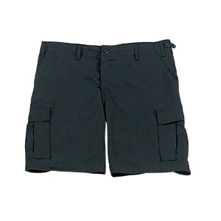
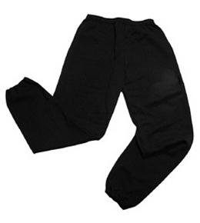
Their kit should consist of a white t-shirt, dark blue or black shorts/jogging bottoms, jumper and trainers/daps.


No jewellery is to be worn; hair needs to be tied back and head scarves must be short and tight fitting. These are all to ensure the safety of your child.

READING
Every child will have their own individual book. It is also important that you listen to your child read books as much as possible, as this will help both their reading and writing abilities. Reading comprehension is a big focus so they will need your support to help practise the skills we will teach. You can help at home by asking your child questions about their book after they have read such as ‘How do you know he is angry?’ or ‘Why is she happy?’

HOMEWORK

Your child will receive homework each week. This homework will be handed out on Friday and should be completed by the following Wednesday. The homework contains a spelling activity, a piece of Maths Homework, which will enable your child to practise what they have been learning in class that week, the previous week, as well as work from previous terms as well.
In preparation for Multiplication Times Tables Check , the children can practise their times tables on https://urbrainy.com/mtc .

If you have any questions, please do not hesitate to contact the school office.

Many Thanks

Miss Thorne, Miss Brazewell and Miss Gheorghe
The Year 4 Team

