Year 5 Autumn Newsletter – Term 1

Dear Parents and Carers,

We hope you are keeping well and your children are happy to be back with us at school for a brand-new school year!

|  |  |
| --- | --- |
| English | Based on our new book ‘The Promise’ by Nicola Davies. This is a fantastic book based around the life of a young person who falls upon hard times and faces a moral dilemma. We will be focusing on varying our sentence structures and using a range of cohesive devices during the first part of the phase. Later in the term, we will be looking at Explanation texts, focussing on structure, layout and technical language. |
| Reading | This term in our reading lessons, our class book is: The Promise. We will be focusing on our skimming and scanning to retrieve information from the book. Children will also be focusing on inferencing skills using the text and pictures, |
| Maths | In maths, we will begin with place value. This will mainly focus on identifying place value markers, reading and writing numerals as digits and words as well as rounding numbers to the nearest 1000, 10,000 and 100,00. We will also be using MOT lessons to recap multiplication facts and skills learnt during Year 4. |
| Science | Year 5 will be learning about properties of materials and what they are most suitable for. They will then be investigating thermal conductors and insulators and looking at which materials will make a lightbulb shine the brightest |
| PE | In PE, we will be covering Rounders. We will be developing our fielding skills, which includes increasing our accuracy in throwing, catching and bowling techniques. We will also become more efficient in striking a ball and thinking about tactics needed to beat opponents. |
| Geography | This term our topic will be geography based. We will be identifying countries of North America and some states. We will use geographical terminology to describe the location and characteristics of a range of places across the Americas. Furthermore, we will develop our understanding of the climates and how animals and plants are adapted to live there. |
| RE | In RE we will be studying Sikhism. Our big question this term is: How far would a Sikh go for his/her religion? Children will have the opportunity to explore the meaning of commitment, drawing on their own ideas and making links to how Sikhs choose to behave and the level of commitment they show. |
| Computing | In computing we will be learning about how to stay safe online. We will be using our SMART rules during our lessons to show how important being safe online is. We will look at self-image and identity. Children will also develop their understanding of systems and searching. |

Additional Information

PE

Year 5 PE is on a Thursday afternoon, however, please note that your child will need to have the correct PE kit in school **every day.**

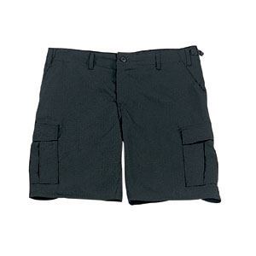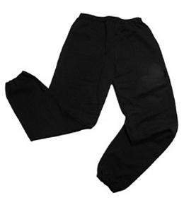Their kit should consist of a white t-shirt, dark blue or black shorts/jogging bottoms and trainers/daps.

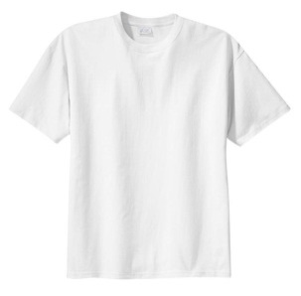

No jewellery is to be worn; hair needs to be tied back and head scarves must be short and tight fitting. These are all to ensure the safety of your child.

**If children wear earrings, they need to be able to take them out (independently) for PE lessons.**

READING

Please listen to your child read every day as this will help both their reading and writing abilities. They all have their own login for Rising Stars (using the same log in and password as Purple Mash). In school, we will be monitoring the books your child reads and the comprehension tasks once complete.

HOMEWORK

Your child will bring maths and spelling homework home on a Friday, to be returned by the following Wednesday. Spellings will be tested weekly on a Friday. They will also be set a text to read on Rising Stars which will need to be completed on Wednesday.

If you have any questions, please do not hesitate to come and see us at the end of the school day.

Many Thanks

Miss Patel, Mrs Wong and Mrs Waller

The Year Five Team