Year 5 Spring Newsletter – Term 3

Dear Parents and Carers,

Happy New Year! We hope you are keeping safe and well and your children are happy to be back with us at school for a brand-new term.

|  |  |
| --- | --- |
| English | In English, our next book for the term will be “The Man Who Walked Between the Towers” by Mordicai Gerstein. We will be looking at developing setting and character descriptions. We will also to look at using a range of subordination in a variety of positions (beginning, middle and end). |
| Reading | This term in our reading lessons, our class book is: |
| Maths | In the first half of the term, we will be focussing on multiplication and division to ensure that all children are confident in using the formal written methods. We will then apply these to our problem solving as we continue to develop our reasoning skills.  Later we will focus on Geometry, discovering how to translate and reflect shapes accurately. |
| Science | This term is Earth and Space, children will be investigating the planets in our solar system and their movement. We will discover how the rotation of the Earth creates night and day as well as how seasons are created. |
| PE | Over the next term, the Year 5 classes will be either participating in Hockey or Drumba. In Hockey, children will be developing their skills, passing, dribbling and shooting with control in a game. They will also develop their understanding of the rules and tactics in both defending and attacking their opponents.  This year we are excited to offer children Drumba as part of the curriculum. This is a high intensity workout which combines PE and Music. Children will be learning drumming skills whilst dancing to an amazing beat! |
| DT | In DT, we will be focussing on designing and creating a mechanical toy using cams to move. We will be exploring how a range of cams work and how this can be incorporated into a mechanical toy design. At the end of the unit, children will learn to evaluate their creations against a design criteria. |
| Topic | In topic, we are focussing on Geography skills through the topic Exploring Europe. We will be looking at countries and cities in Europe, the climate in eastern European regions and finding out where our food comes from. |
| RE | In RE our big question is: How are sacred teachings and stories interpreted by Sikhs today? In this unit, the children talk about some important Sikh stories and teachings and consider what message Sikhs can get from these today. |
| Computing | In Computing, children will be learning how to programme micro:bits and explore the concept of selection in programming. We will also be looking at how to judge whether information online can be trusted in Online Safety and learning about online bullying. We will be using our SMART rules during our lessons to show how important being safe online is. We will look at how anyone can get help if they are being bullied online and identify when to tell a trusted adult. |

Additional Information

PE

Year 5 PE is on a Tuesday afternoon, however, please note that your child will need to have the correct PE kit in school **every day.**

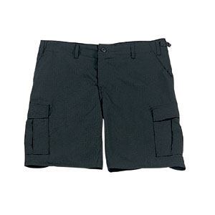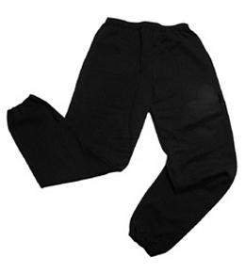Their kit should consist of a white t-shirt, dark blue or black shorts/jogging bottoms and trainers/daps.

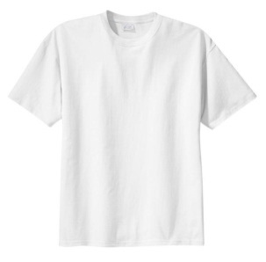

No jewellery is to be worn; hair needs to be tied back and head scarves must be short and tight fitting. These are all to ensure the safety of your child.

**If children wear earrings, they need to be able to take them out (independently) for PE lessons.**

HOMEWORK

Your child will bring maths, reading comprehension and spelling homework home on a Friday, to be returned by the following Wednesday. Spellings will be tested weekly on a Thursday. They will also be set a text to read on Boost which will need to be completed by Wednesday along with 2 reads written in their reading records.

If you have any questions, please do not hesitate to come and see us at the end of the school day.

Many Thanks

Mrs Waller, Miss Wong and Mr Roberts

The Year Five Team