Year 5 Spring Newsletter – Term 4

Dear Parents and Carers,

We are looking forward to another fantastic term!

|  |  |
| --- | --- |
| English | In English, our next book for the term will be ‘Wonder’. Children will be identifying the main themes of the story to influence and develop characters in their own writing. They will focus on using subordinate and relative clauses , as well and using a range of cohesive devices to write a short narrative. |
| Reading | We’re going to be reading ‘Wonder’ by R.J. Palacio. We will be practising retrieval skills, making predictions and answering more complex inference questions. Later in the term, we will look at a range of non-fiction texts to support our writing |
| Maths | In the first half of the term, we will be focussing on fractions, decimals and percentages. Later on, we will be converting units of length (kilometres, metres and centimetres); units of weight (kilograms and grams) and units of capacity (litres to millilitres). |
| Science | Science this term covers ‘All Living Things and Their Habitats’. Children will be able to describe and compare the life cycles of different animals, finding similarities and differences. They will describe the life cycle of plants and identify the reproductive parts of a flowering plant, then explaining how plants reproduce. |
| PE | In PE we will be doing football this term. We will be developing our football skills such as dribbling, defending and attacking opponents. We will then apply these skills to a series of matches. |
| History | Our history topic this term is “The Maya Civilisation”. We will be exploring what and when the Maya period was, as well as examining various sources to understand more about the Maya civilisation. We will be looking at Maya culture and everyday life as we explore Mayan writing systems and the Mayan religion. |
| RE | In RE our big question is: How significant is it for Christians to believe God intended Jesus to die? The children will explore this through discussions and shared experiences about the story of Easter and Holy Week. We will also visit Gorse hill Baptist Church for the children to engage in Easter activities and find out more about the events leading up to Easter. |
| Computing | Computing this term will be exploring data and information through Flat-file Databases. We will be exploring the different tolls than can be used to compare and sort data, as well as using real-world databases to answer questions. We will also be exploring Online Safety through looking at health and wellbeing in regards to technology. |

Additional Information

PE

Year 5 PE is on a Tuesday afternoon. Children will need to bring their PE kits in for the whole week.

Please ensure they are in the correct clothes and that they will be warm enough, especially as we will be doing PE outside during the colder months. A good waterproof coat will be needed.

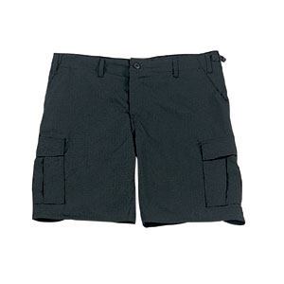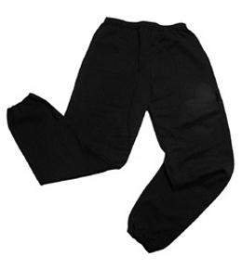Their kit should consist of a **white t-shirt**, dark blue or black **shorts/jogging bottoms** and **trainers**. Daps are ok but will quickly get wet if we are doing PE outside during winter, trainers would be more suitable.



No jewellery is to be worn; hair needs to be tied back and head scarves must be short and tight fitting. These are all to ensure the safety of your child. **If children wear earrings, they need to be able to take them out (independently) for PE lessons.**

READING

Listening to your child read every day will help them to improve their fluency and comprehension. They can read their own books at home and access Boost. Reading comprehension is vital so they will need your support to help practice the skills we will teach. You can help at home by asking your child questions about their book after they have read such as ‘How do you know he is angry?’ or ‘Why is she happy?’

HOMEWORK

Your child will be given **three pieces of homework** to complete on a Friday, to be returned by the following Wednesday. This will include spelling homework (which will be tested weekly), maths to recap prior learning and a reading comprehension.

If you have any questions, please do not hesitate to come and see us at the end of the school day.

Many Thanks

Mrs Waller, Mr Roberts and Miss Wong.

The Year Five Team