Year 5 Spring Newsletter – Term 4

Dear Parents and Carers,

We are looking forward to another fantastic term!

|  |  |
| --- | --- |
| English | In English, our next book for the term will be ‘The Boy at the Back of the Class.’ This book is all about a refugee boy coming to a UK school from a warzone. We will be looking at writing a diary about how it may feel to start a new school. We will also be writing a report about a key event in the story. Each week, we will have a different skill that we will be focusing on. This term, we will be looking at using: commas and relative pronouns accurately in a relative clause; dashes for after thoughts and tenses. |
| Reading | We’re going to be reading ‘The Boy at the Back of the Class’ by Onjali Q. Rauf. We will be practising retrieval skills, making predictions and answering more complex inference questions. Later in the term, we will look at a range of non-fiction texts to support our writing |
| Maths | In the first half of the term, we will be focussing on fractions, decimals and percentages. Later on, we will be converting units of length (kilometres, metres and centimetres); units of weight (kilograms and grams) and units of capacity (litres to millilitres). |
| Science | Science this term covers ‘All Living Things and Their Habitats’. Children will be able to describe and compare the life cycles of different animals, finding similarities and differences. They will describe the life cycle of plants and identify the reproductive parts of a flowering plant, then explaining how plants reproduce. |
| PE | In PE we will be continuing Dance, a specialist will be joining us from Swindon dance to teach the children break dancing. They will look at different ways of travelling and using space, whilst developing timings. As the term progresses, they will have opportunities to create their own routines or in a small group, and evaluate their own and others performances. |
| History | In History, we are learning all about the Tudors. We will start chronologically at the beginning of the Tudor period with the Battle of Bosworth. We will then learn all about the infamous King Henry VIII and his many wives and his descendants.  As part of our learning, we will also be going on an exciting trip to Tudor World in Stratford-Upon -Avon. The trip will be on the 18th March and children will need to be in school by 8am. For more information please ask your class teacher or check the letter that was previously sent in Term 3. |
| RE | In RE our big question is: How significant is it for Christians to believe God intended Jesus to die? The children will explore this through discussions and shared experiences about the story of Easter and Holy Week. We will also visit Gorse hill Baptist Church for the children to engage in Easter activities and find out more about the events leading up to Easter. |
| Computing | Computing this term will be exploring data and information through Flat-file Databases. We will be exploring the different tolls than can be used to compare and sort data, as well as using real-world databases to answer questions. We will also be exploring Online Safety though looking at health and wellbeing in regards to technology. |

Additional Information

PE

Year 5 PE is on a Thursday afternoon. Children will need to bring their PE kits in for the whole week.

Please ensure they are in the correct clothes and that they will be warm enough, especially as we will be doing PE outside during the colder months. A good waterproof coat will be needed.

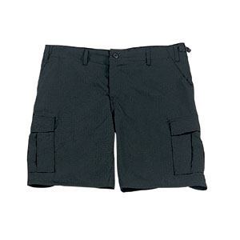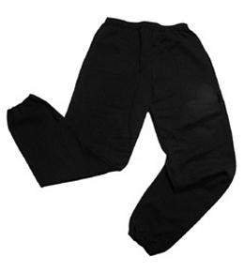Their kit should consist of a **white t-shirt**, dark blue or black **shorts/jogging bottoms** and **trainers**. Daps are ok but will quickly get wet if we are doing PE outside during winter, trainers would be more suitable.



No jewellery is to be worn; hair needs to be tied back and head scarves must be short and tight fitting. These are all to ensure the safety of your child. **If children wear earrings, they need to be able to take them out (independently) for PE lessons.**

READING

Listening to your child read every day will help them to improve their fluency and comprehension. They can read their own books at home and access Boost. Reading comprehension is vital so they will need your support to help practice the skills we will teach. You can help at home by asking your child questions about their book after they have read such as ‘How do you know he is angry?’ or ‘Why is she happy?’

HOMEWORK

Your child will be given **three pieces of homework** to complete on a Friday, to be returned by the following Wednesday. This will include spelling homework (which will be tested weekly), maths to recap prior learning and a reading comprehension.

If you have any questions, please do not hesitate to come and see us at the end of the school day.

Many Thanks

Mrs Waller, Miss Picton and Miss Wong.

The Year Five Team