Year 5 Summer Newsletter – Term 6

Dear Parents and Carers,

We hope you have had a lovely half term break and you are ready for the last term of Year 5! As it is getting warmer, please ensure that children always come to school with a water bottle and a sun hat. Sun cream should be applied at home, though some may wish to have a small bottle with them for extra use. We will not be providing sun cream at school.

|  |  |
| --- | --- |
| English | In English, our next book for the term will be ‘The Last Alchemist’. In writing, we will be producing two writing outcomes: a narrative setting description (fiction) and a non-chronological report (non-fiction). For our first unit of writing, will focus on skills used to write a narrative including, but not limited to: coordinating conjunctions and figurative language such as alliteration, similes and personification. For our second writing outcome, we will learn about how formal language and third person will ensure the report is appropriate. |
| Reading | We’re going to be reading ‘The Last Alchemist’ by Colin Thompson. We will be practising retrieval skills, making predictions and answering more complex inference questions. Later in the term, we will look at a range of texts and non-chronological reports to support our writing. |
| Maths | We will be learning how to measure and draw acute, obtuse and reflex angles and measure angles on a line and around a point. Accuracy is very important when measuring the angles as the measurement needs to be accurate within 2°. The last skills to be learnt will be reading a 24-hour digital clock and converting between 12-hour analogue and 24-hour notation. Using that information, we will then learn how to read and interpret information in tables and line graphs. |
| Geography | In geography, we will be answering the question ‘How did a sandwich change Swindon?’. To learn about our place in the UK, we will look at a map of the UK and find out about how regions and counties split the country up. Then, we will learn about the changes Swindon has been through using a range of maps from the 1800s to the current day. Knowing the 8 points of a compass is an important skill and that will be covered alongside learning how to use grid references. |
| Science | In Science, we will be learning about ‘Animals including Humans’. We will be understanding the development of a baby and explaining the changes that take place into old age. Towards the end of the term, we will be completing a TAPS assessment that shows our observation of children from reception – year 6 and draw conclusions from our recorded findings. |
| RE | In RE our big question is: Does belief in the Trinity help Christians make better sense of God as a whole? Children will have the opportunity to explore reasons why Christians believe in the Holy Trinity and how this helps them understand Gods existence and power. |
| Computing | In Computing, we will develop our knowledge of ‘selection’ by revisiting how ‘conditions’ can be used in programming, and then learning how the ‘if… then… else...’ structure can be used to select different outcomes depending on whether a condition is ‘true’ or ‘false’. These skills will then be used to design a quiz in response to a given task and implement it as a program. |
| DT | This term, we will be building bridges. We will start by examining work by Isambard Kingdom Brunel, and identifying different types of bridges and the materials they are built from and why. As part of the planning process children will explore how to stabilise and strengthen their structures before building their wooden structure. |
| PSHE | In Term 6, our PSHE focus will be Changing Me. This will include learning about self-image and puberty for both boys and girls. These lessons are compulsory and families are not able to 'opt out' of the lessons. We will not be teaching about conception. |

Additional Information

PE

Year 5 PE is on a Thursday afternoon. Children will need to bring their PE kits in for the whole week. Their kit should consist of a **white t-shirt**, dark blue or black **shorts/jogging bottoms** and **trainers**. A sun hat or cap may be useful during the summer months.

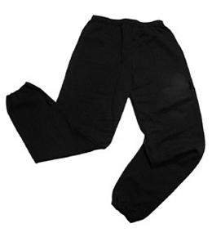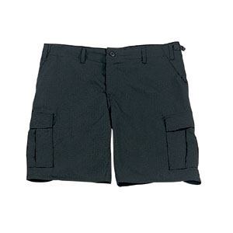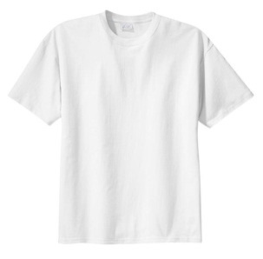

No jewellery is to be worn; hair needs to be tied back and head scarves must be short and tight fitting. These are all to ensure the safety of your child. **If children wear earrings, they need to be able to take them out (independently) for PE lessons or cover up.**

READING

Listening to your child read every day will help them to improve their fluency and comprehension. They can read their own books at home and access Boost. Reading comprehension is vital so they will need your support to help practice the skills we will teach. You can help at home by asking your child questions about their book after they have read such as ‘How do you know he is angry?’ or ‘Why is she happy?’

HOMEWORK

Your child will be given **homework** to complete on a Friday, to be returned by the following Wednesday. This will include spelling homework (which will be tested weekly), maths to recap prior learning and a short reading comprehension.

If you have any questions, please do not hesitate to come and see us at the end of the school day.

Many Thanks

Mrs Waller, Miss Picton and Miss Wong.

The Year Five Team