Year 6 Term 4 Newsletter

Dear Parents and Carers,

Welcome back to term 4, we hope that you are all keeping well.
This term, we will be learning all about mapping in our geography lessons. In science, we are moving onto a new physics topic about light and in RE we will continue to look at Christianity as we head towards Easter. We will keep building on our year 6 writing skills in fiction and non-fiction genres and we will continue to practise reading comprehensions in a variety of different genres. In maths we will look at position and direction, statistics and algebra.

PE
This year our PE session is on a Thursday afternoon. All children must arrive to school in their uniform.
Their kit should consist of a white t-shirt, dark blue or black shorts/jogging bottoms, jumper and trainers/daps.

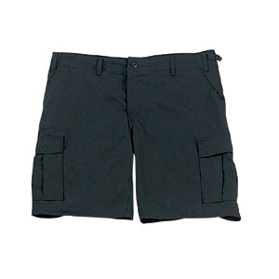
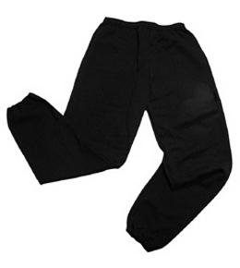
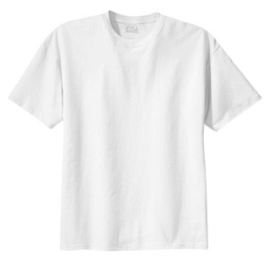

No jewellery is to be worn; hair needs to be tied back and head scarves must be short and tight fitting. These are to ensure the safety of your child.

READING

It is also important that you listen to your child read books as much as possible, as this will help both their reading and writing abilities.

HOMEWORK
Your child will receive homework each week. This homework will be set on Friday and should be completed by the following Wednesday. Each week, your child will be set one spelling task, one maths task and a reading task.

If you have any questions, please do not hesitate to contact the school office.

Many Thanks
Mrs Ramzan, Mrs Vernon and Mr Richardson
The Year 6 Team

