Year 6 Term 4 Newsletter

Dear Parents and Carers,

Welcome back to term 4, we hope that you are all keeping well.

This term, we will be learning all about mapping in our geography lessons. In science, we are moving onto a new biology topic about evolution and in RE we will continue to look at Christianity as we head towards Easter. We will keep building on our year 6 writing skills in fiction and non-fiction genres and we will continue to practise reading comprehensions in a variety of different genres. This is the last full term before SATs in May so a very busy and important term for Year 6!. Please remember to return the permission slip for our trip to Paulton’s Park if you haven’t already.

PE

This year our PE session is on a Monday. All children must arrive to school in their uniform.

Their kit should consist of a white t-shirt, dark blue or black shorts/jogging bottoms, jumper and trainers/daps.

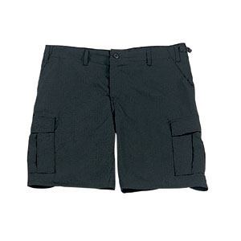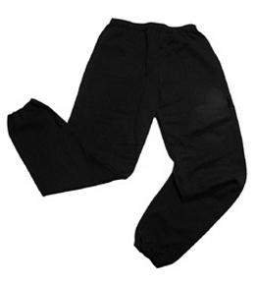 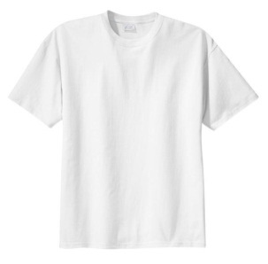

**No jewellery is to be worn; hair needs to be tied back and head scarves must be short and tight fitting.** These are to ensure the safety of your child.

READING

**It is also important that you listen to your child read books as much as possible, as this will help both their reading and writing abilities.**

HOMEWORK

Your child will receive homework each week. This homework will be set on **Friday** and should be completed by the following **Wednesday**. Each week, your child will be set one spelling task, one maths task and a reading task. In Term 2 every Wednesday lunchtime homework clubs will take place across Year 6. If you would like your child to drop into a session, please let your class teacher know.

If you have any questions, please do not hesitate to contact the school office.

Many Thanks

Mrs Ramzan, Mrs Vernon and Mr Richardson

The Year 6 Team