Year 6 Summer 2 Newsletter

Dear Parents and Carers,

Welcome back to the final Summer term, we hope that you are all keeping well. This is an exciting term as there are lots of events on the Year 6 calendar, so please keep an eye out for updates. On Tuesday 4th June, we will be going on our end of year trip to Paulton’s Park which we are all eagerly anticipating. We are going to be busy rehearsing our play, “I’m an Eleven Year Old – Get Me Our of Here!!”. There is also Sports Day, Drove’s GotTalent, the summer fete, the end of year prom and our leavers assembly.

This term we will also be preparing the children for their transitions to Year 7 in September. You should have all been informed by your child’s new school when this will take place. On these days, they will need to attend in their Drove uniform, but do not need to come here first. Most of these days are happening on the week beginning 24th June.

PE

This year our PE session is on a Monday. We are being supported by a cricket coach who will rotate around each class to support with the teaching of cricket in PE in term 6. All children must bring to school in their uniform.

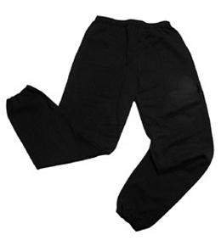Their kit should consist of a white t-shirt, dark blue or black shorts/jogging bottoms, jumper and trainers/daps.



**No jewellery is to be worn; hair needs to be tied back and head scarves must be short and tight fitting.** These are to ensure the safety of your child.

PHSE

In Term 6, our PHSE unit is called ‘Changing me.’ The children will learn about puberty and also focus on self-image and relationships. We will also help the children to prepare for their transition to secondary school. These lessons are all compulsory and part of the National Curriculum. We would encourage you to discuss these topics further at home with your child.

READING

Every child will have their own individual log in for Rising Stars Reading Planet to access books set by the class teacher. To access the Reading Planet, search for ‘my rising stars’ on Google. Then enter the user name and password which has not changed from previous years.

It is also important that you listen to your child read books as much as possible, as this will help both their reading and writing abilities.

Many Thanks

Mrs Ramzan, Mrs Vernon and Mr Richardson

The Year 6 Team