What should I already know?
(Substantive Knowledge)
- Understand drawing is a physical activity.

- Introduce what a sketchbook is for. Understand it is owned by the pupil for experimentation and exploration.

- Understand prints are made by transferring an image from one surface to another.

- Look at the work of artists who draw, sculptors, and painters, listening to the artists’ intention behind the work and the context in which it was made.
Key Vocabulary:

Sketchbook  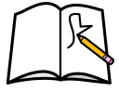 | A book or pad of drawing paper for sketches.
Scale  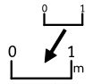 | How nig or small something is to the real thing.
Emotions   | How someone feels about something
Line | An path created by a point moving creating a shape.
Blending  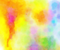 | The process of putting two colors together so that the paint moves from one color to another, or combines to create a new color.
Composition  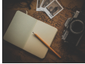 | The way something is put together in a piece of art or a photograph.

What will I learn?
(Implicit Knowledge/Skills)

- Explore lines made by a drawing tool, made by moving fingers, wrist, elbow, shoulder and body. Work at a scale to accommodate exploration.

- Use colour (pastels, chalks) intuitively to develop spiral drawings.

- Make a simple elastic band sketchbook. Personalise it.

- Develop experience of primary and secondary colours.

- Practice observational drawing.

- Explore mark making.

- Reflect upon the artists’ work, and share your response verbally (“I liked…”).

Focus Artists

Molly Haslund

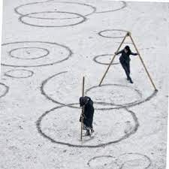

Blooms Taxonomy – Specific Verbs to Use in Lesson Aims
Knowledge: Describe, find, identify, list, locate, name, recognise, retrieve Comprehension: Classify, compare, explain, infer, interpret, paraphrase, summarise Application: Carry out, implement, use Analysis: Deconstruct, Organise, outline, structure Synthesis: Construct, design, devise, invent, make, plan, produce, Evaluation: Appraise, assess, choose,

Glue here.
My Learning Ladder

Learning Objective |  | Pupil Voice | Teacher Assessment
to look at the work of Molly Haslund and create a large-scale spiral drawing
to explore line and blending by creating a snail drawing
to make my sketchbook my own by adding spaces and places
to explore drawing natural forms with continuous lines

to explore drawing natural forms with pens and water

to evaluate my natural form drawings |  | See below.
Evaluation of my Final Piece


