Key Vocabulary and Definitions:

Autumn  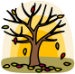 | One of the four seasons, after summer and before winter.
Bar chart  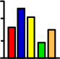 | A chart that shows information with bars to make it easy to compare.
Climate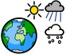 | The usual weather conditions in a certain place.
Diagram  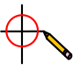 | A drawing or plan that shows the parts of something or how the parts work together.
Season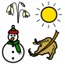 | One of the four parts of the year; spring, summer, autumn, and winter, marked by particular weather patterns.
Spring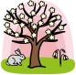 | One of the four seasons, after winter and before summer.
Summer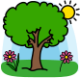 | One of the four seasons, after spring and before autumn.
Weather  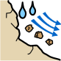 | What it is like outside at a particular time, temperature, cloudiness, dryness, sunshine, wind, rain, etc.
Winter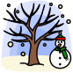 | One of the four seasons, after autumn and before spring.

What should I already know?
• Understand the key features of the life cycle of a plant and an animal. (Nursery – Plants & Animals, excluding humans)
• Explore the natural world around them. (Reception – Seasonal changes)
• Describe what they see, hear and feel whilst outside. (Reception – Seasonal changes)
• Understand the effect of changing seasons on the natural world around them. (Reception – Seasonal changes)

Scientific Knowledge:
Observe changes across the four seasons and make simple comparisons.
Observe and describe weather associated with the seasons and how day length varies.
Make observations using appropriate senses.

Blooms Taxonomy – Specific Verbs to Use in Lesson Aims
Knowledge: Describe, find, identify, list, locate, name, recognise, retrieve Comprehension: Classify, compare, explain, infer, interpret, paraphrase, summarise Application: Carry out, implement, use Analysis: Deconstruct, Organise, outline, structure Synthesis: Construct, design, devise, invent, make, plan, produce, Evaluation: Appraise, assess, choose,

Teaching Sequence

- To name the four seasons and talk about key features of them.
- To create a simple chart to show the pattern of weather over a period of time.
- Local walk [Link to TAPs Assessment] Observe the signs of the season.
- To compare and discuss changes that occur in the weather across the seasons.
- To review the weather chart created.

Scientific Skills:
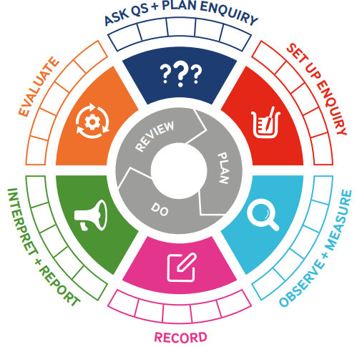
Term 3 | Let’s Talk (Explorify) | Scientific Knowledge | Scientific skill
Lesson 1 | Have you Ever  Played in the Autumn Leaves?  Have you Ever  Seen Trees in Winter with lots of leaves? | To name the four seasons and talk about key features of them. | To observe
Lesson 2 | What’s Going On?  Wonderful Weather | To create a simple chart to show the pattern of weather over a period of time. | Set up Enquiry  Ask Q’s and Plan Enquiry
Lesson 3 | What’s Going on  Seasons | Local walk [Link to TAPs Assessment] Observe the signs of the season. | To Observe and Measure  To Record  Evaluate
Lesson 4 | Odd one out  Unusual houses | To compare and discuss changes that occur in the weather across the seasons. | Plan a scientific enquiry to answer a question recognising and controlling variables. (TAPS)
Lesson 5 | Odd one out  Winter Scenes | To review the weather chart created. | Interpret and Report  Evaluate

