Key Vocabulary and Definitions:
Celestial | 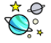 | Relating to the sky or outer space.
Earth |  | The planet on which we live.
Moon |  | A planetary object which orbits the Earth’s gravitational field.
Orbit | 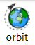 | The curved path of a celestial object or spacecraft around a star, planet, or moon.
Planets |  | A celestial body moving in orbit around a star.
Rotate |  | To move in a circle around an axis or centre.
Solar System | 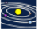 | The collection of 8 planets and their moons in orbit around the sun.
Spherical |  | A three-dimensional circle, relating to the properties of spheres.
Sun | 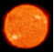 | The star around which the Earth orbits.
Star |  | A large ball of burning gas in space that is usually seen from Earth as a point of light in the sky.

What should I already know?
- Explore the natural world around them. (Reception – Earth and space)
- Describe what they see, hear and feel whilst outside. (Reception – Earth and space)
- Observe changes across the four seasons. (Y1 - Seasonal changes)
- Observe and describe weather associated with the seasons and how day length varies. (Y1 - Seasonal changes)

Scientific Skills:
- Describe the movement of the Earth, and other planets, relative to the Sun in the solar system.
- Describe the movement of the Moon relative to the Earth.
- Describe the Sun, Earth and Moon as approximately spherical bodies.
- Use the idea of the Earth’s rotation to explain day and night and the apparent movement of the Sun across the sky
- Report and present findings from enquiries using appropriate scientific language (TAPS)

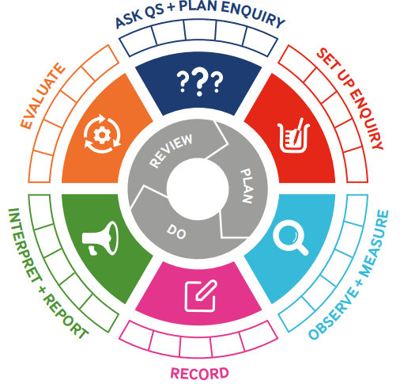
Teaching Sequence
- To describe the movements of the Sun, Earth and Moon.
- To explore how the rotation of Earth creates day and night.
- To learn about how Earth’s tilt creates seasons.
- To discover how theories about our solar system have changed.
- To investigate the planets in the solar system (TAPS).
Blooms Taxonomy – Specific Verbs to Use in Lesson Aims
Knowledge: Describe, find, identify, list, locate, name, recognise, retrieve Comprehension: Classify, compare, explain, infer, interpret, paraphrase, summarise Application: Carry out, implement, use Analysis: Deconstruct, Organise, outline, structure Synthesis: Construct, design, devise, invent, make, plan, produce, Evaluation: Appraise, assess, choose,

Scientific Skills:
Term 2 | Let’s Talk (Explorify) | Scientific Knowledge | Scientific skill
Lesson 1 | Goldilocks planets - Explorify | - Describe the movement of the Earth, and other planets, relative to the Sun in the solar system.  - Describe the Sun, Earth and Moon as approximately spherical bodies. | To Observe and Measure
Lesson 2 | There was no Moon? - Explorify | - Use the idea of the Earth’s rotation to explain day and night and the apparent movement of the Sun across the sky  - Describe the Sun, Earth and Moon as approximately spherical bodies. | To Observe and Measure
Lesson 3 | To the Moon and beyond - Explorify | - Describe the Sun, Earth and Moon as approximately spherical bodies. | To Observe
Lesson 4 | The Sun rotated and the Earth didn't? - Explorify | - Describe the movement of the Earth, and other planets, relative to the Sun in the solar system. | Interpret and Report  Report and present findings from enquiries using appropriate scientific language (TAPS)
Lesson 5 | Earth - Explorify |  | Interpret and Report

