Progression
- This unit progresses students’ knowledge and understanding of grouping data. It builds on the Year 1 Data and Information unit where learners labelled objects and grouped them based on different properties. In Year 3 learners develop their understanding of attributes (properties) using branching databases to structure data according to different object attributes.

Key Vocabulary and Definitions:
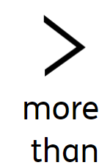 | A higher value
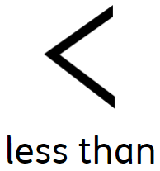 | A lesser/smaller value
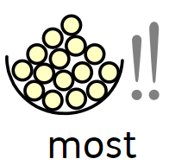 | Greatest in amount
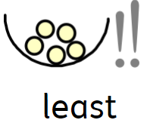 | the smallest value or amount.
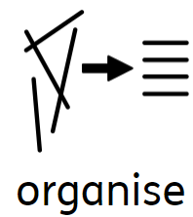 | Order and arrange combinations of objects in patterns and sequences teaching
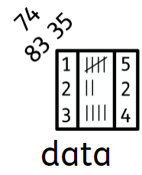 | A collection of information. gathered by observation, questioning or measurement. Data is often organised in graphs or charts for analysis and. may include facts, numbers or measurements.
Object | An object is something that you can touch. A material is what the object is made from.
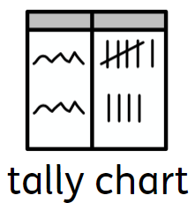 | A tally chart is a table used for counting and comparing the numbers of multiple classes of a data set.
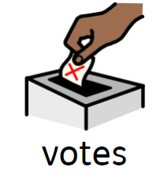 | Individual choice
total | The result of adding.

National Curriculum
- Use technology purposefully to create, organise, store, manipulate and retrieve digital content
- Use technology safely and respectfully, keeping personal information private; identify where to go for help and support when they have concerns about content or contact on the internet or other online technologies

Teaching Sequence
Computing Science
- To recognise that we can count and compare objects using tally charts.
- To recognise that objects can be represented as pictures
- To create a pictogram
- To select objects by attribute and make comparisons
- To recognise that people can be described by attributes
- To explain that we can present information using a computer
Online safety – Online Bullying
- To explain how information put online about someone can last for a long time
- To recognise that devices can be connected via networks.
- To describe how anyone’s online information could be seen by others.
- To know who to talk to if something has been put online without consent or if it is incorrect.

Blooms Taxonomy – Specific Verbs to Use in Lesson Aims
Knowledge: Describe, find, identify, list, locate, name, recognise, retrieve Comprehension: Classify, compare, explain, infer, interpret, paraphrase, summarise Application: Carry out, implement, use Analysis: Deconstruct, Organise, outline, structure Synthesis: Construct, design, devise, invent, make, plan, produce, Evaluation: Appraise, assess, choose,

Final outcome:

Concept Cartoon:

